Name:__________________________ Date:____________ Light Study Guide
Use these study questions to help you prepare for your test. Use the back if needed to answer.

1.Fill in the blank with the correct term:  A. Light bouncing back:___________________  B. Light striking an object:_________________  C. Light Bending:________________________  D. Light going through:___________________ | 2. Using the picture: Explain why the person can see the other person. Remember key words!  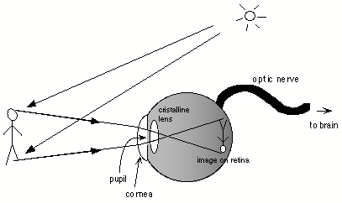  This Photo by Unknown Author is licensed under CC BY-SA
3. Draw and label a model for light reflecting, transmitting, absorbing, and refracting. Explain your models.

4. If the incoming ray has an angle of 35 degrees, what is the outcoming ray_____________?  What law tells you this? | 5. Refraction happens when………
6. Explain the reflection for:  Smooth Surface:  Rough Surface: | 7. Explain how a one way mirror works. Use key words.
8. Define the following materials and give examples.  Opaque:  Transparent:  Translucent: | 9. Explain why I see an apple as red.
10. Explain how the amount of light can affect what we see.

