Did I help take attendance?
Did I walk nicely in the hallway?
Did I greet Ms. Bethania?
Did I turn in the attendance form?
Did I say “Have a nice day” to Ms. Bethania?

Did I help take attendance? |  | 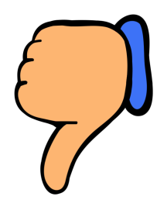
Did I walk nicely in the hallway?
Did I greet Ms. Bethania?
Did I turn in the attendance form?
Did I say “Have a nice day” to Ms. Bethania?

