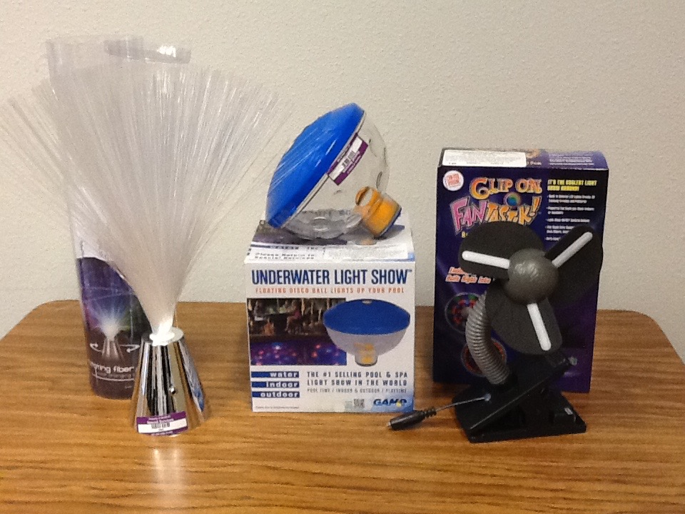

Sensory Items

- Fiber Optic Light

- Underwater Light Show

- Clip on Fantastik

