Name: Date:

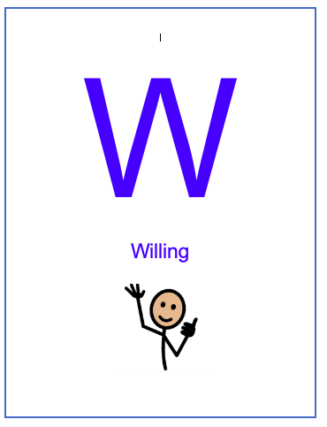
We W.O.R.K. Self- Assessment: Willing

Directions: Being willing is an important part of being able to work. Put a check mark under the qualities of being willing to do your work that you demonstrated in this assignment.

What was your assignment?

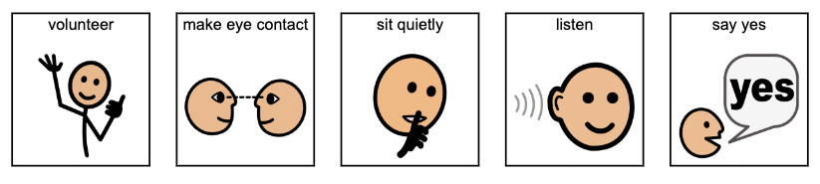

Did you show that you were willing to learn?  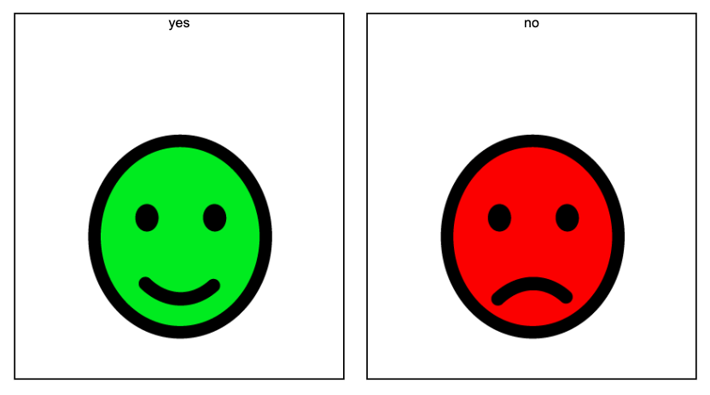  YES NO | How did it feel to be willing?  Good Bad Try Again

Staff Comments:

Name: Date:

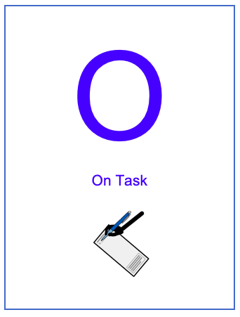
We W.O.R.K. Self- Assessment: On Task

Directions: Being on task is an important part of being able to work. Put a check mark under the qualities of being on task that you demonstrated in this assignment.

What was your assignment?

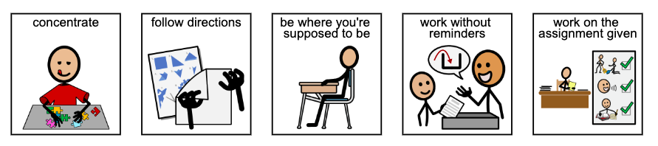

Did you show that you were on task?  YES NO | How did it feel to be on task?  Good Bad Try Again

Staff Comments:

Name: Date:

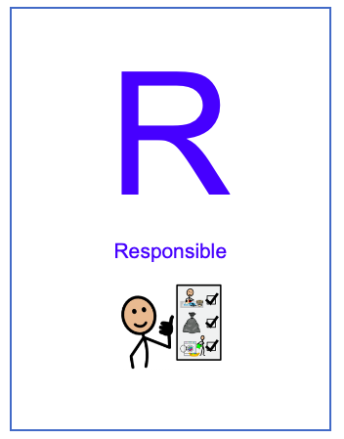
We W.O.R.K. Self- Assessment: Responsible

Directions: Being responsible is an important part of being able to work. Put a check mark under the qualities of being responsible that you demonstrated in this assignment.

What was your assignment?

Did you show that you were responsible?  Yes No | How did it feel to be responsible?  Good Bad Try Again

Staff Comments:

Name: Date:
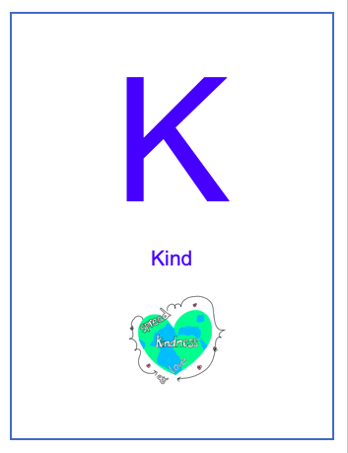
We W.O.R.K. Self- Assessment: Kind

Directions: Being kind is an important part of being able to work. Put a check mark under the qualities of being responsible that you demonstrated in this assignment.

What was your assignment?

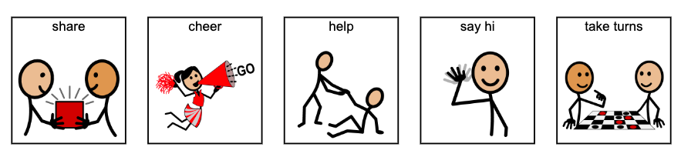

Did you show that you were kind?  Yes No | How did it feel to be kind?  Good Bad Try Again

Staff Comments:

Name: Date:

We W.O.R.K. Self- Assessment

Directions: Being willing, on task, responsible, and kind is an important part of being able to do good work. Put a check mark under the W.O.R.K. habits that you demonstrated in this assignment.

What was your assignment?

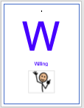 | 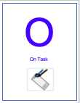 | 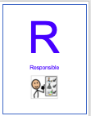 | 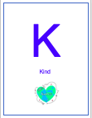

Did you show good work habits?  YES NO | How did it feel to show good work habits?  Good Bad Try Again

Staff Comments:

