Tel: (929) 397-3340
Fax: (929) 397-3339
Founding Principal, Marcella Carr-Gay A Jewel in Crown Heights
130 Rochester Avenue
Brooklyn, NY 11213

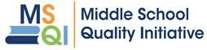

Summer Reading Challenge
2020

Contents (click on the links below to get to each part of the challenge)
1. | Summer Reading Project Overview
2. | Summer Reading Goals
3. | My Reading Plan
4. | Book Lists
5. | Weekly Logs
6. | Letter about a Book
7. | Family Tips for Supporting your Middle School Reader
8. | Family Email
Summer Reading Project Overview

Dear Student,
Congratulations on finishing this very different type of school year! Even though there are a lot of questions about next year, this summer is still an excellent opportunity to prepare and sharpen your reading skills. Reading regularly – and reflecting on your reading – is so important for improving your reading, writing, vocabulary, thinking, and learning. The only way to get better at anything in life is to devote time to it!
Here is an overview of your reading challenge for the summer:
- Read at least 150 minutes per week (or more than 2 ½ hours every week; this could be 30 minutes 5 days a week or read for longer chunks to build stamina). Read a mix of fiction and nonfiction.
- DAILY: on attached logs:
  - Record what you read each day
  - At the end of the week, write a paragraph reflecting on your reading.
- End of Summer: Choose something you read over the summer and write a letter to your teacher or classmates about why it is an important book or text to read – see the attached “Letter about a Book” for more directions.
  - Include the title, author, and a brief summary of the book or text
  - Provide reasons and evidence for why the book or text is important to read (consider character decisions, the conflict/s in the book, connections to your life or the world, themes and lessons, etc.)
Tips:
- Choose “just right” books near your level – not too easy and not too hard to understand. If there are five words on a page that you don’t understand, the book might be too hard.
- Find friends or family members to recommend books, who want to read the same texts as you, and/or who will talk with you about your reading.
- Choose a mix of fiction and nonfiction books that interest you to read. You may also read magazines and newspapers or other articles.
- Use online resources to borrow e-books and find texts. You can find information about your public library online at NYPL.org, BrooklynLibrary.org, or QueensLibrary.org. Get a free library card if you don’t have one. Find book lists and reading opportunities at SummerReading.org
Challenge Winners:
- You win this challenge by completing the FULL Summer Reading assignment (a paragraph per week + letter about a book)
- Once you win, you will get to pick out 2 new books of your choice for your home libraries.

Student Name:

Summer Reading Goals

Over the summer, a young person who does not read can lose a quarter of the reading growth they made the previous year. If a middle school student reads just 5 books at their level during the summer months, they are far less likely to slide backwards. Students who read at home at least 3 times a week are twice as likely to score in the top 25% of their class in reading comprehension. Setting goals helps you to stay accountable to yourself. Goals also help you track your progress and they give you the opportunity to celebrate your successes.

My Summer Reading Goals:

- I will read

books this summer.

- To reach my goal, I can and will read for:
minutes
days a week

My Reading Plan:
Directions: Type / write your responses in the boxes provided.

- What are some books, authors, genres, magazines or topics about which you want to read? (Type in the box below.)

- What times and places are best for you to complete your reading? (Type in the box below.)

- Who will be best to keep you on track and talk with you about your reading this summer? (Type in the box below.)

Where to Find E-books and Other Texts Online

Website | Description
NY Public Library | You can access free ebooks and other resources using your library card. You can apply for a free card through the nypl.org website. You can live anywhere in NYC to get a card.
Brooklyn Public Library | You can access free ebooks and other resources using your library card. You can apply for a free card through bklynlibrary.org website. You can live anywhere in NYC to get a card.
Queens Public Library | You can access ebooks and other resources using your library card. You can apply for a free card through queenslibrary.org website. You can live anywhere in NYC to get a card.
Open Library | You will need to create a free account using an email address. After you have an account, this site lets you borrow books similar to an online public library.
Audible | You have free access to a small collection of audio books.
Epointplus | You have free access to a collection of e-books, mostly nonfiction.
Tumblebooks | Your teacher needs to sign up first and provide you with a code to access books on this website. Registration is free for your teacher.
Poetry Foundation | You can access a variety of poems for free.
New York City School Library System Gale Database | You have access to this database where you can search for articles in popular newspapers and magazines.
National Geographic Kids | You have free access to nonfiction articles on science and social studies topics from National Geographic Magazine for Kids.
Scholastic Magazine | You have free access to articles and short stories selected from various Scholastic magazines.
Smithsonian Tween Tribune | You have free access to articles on current events, history, art, culture and science.
SI Kids: Sports News for Kids, Kids Games and More | You have free access to sports-themed articles from Sports Illustrated for Kids
Newsela | If you don’t already have access through your school, your teacher or parent will need to set up an account and share a code. Then you will have access to a variety of articles on current events, history, art, culture, and science as well as some fiction.
Free Comics from Amazon | You can read a selection of comic books for free through Amazon, including The Avengers and Black Panther.

Book Lists- curated by the Middle School Quality Initiative
*Denotes mature content - book may be better suited to older middle school students.
Identity/Culture/Sexuality | Coming of Age
The Word Collector, Peter H. Reynolds, 490L  Last Stop on Market Street, Matt de la Pena, Level M/610L  Absolutely True Diary of a Part Time Indian, Sherman Alexie*, Level Z+/600L  Simon vs. the Homo Sapiens Agenda, Albertalli, Level Z+/HL640L  The First Rule of Punk, Celia C. Perez, Level T/670L  Piecing Me Together, Renee Watson, Level Z/680L  Mexican Whiteboy, Matt de la Pena*, Level Z+/680L  Crown: An Ode to the Fresh Cut, Derrick Barnes, 700L  Clayton Bird Goes Underground, Williams-Garcia, Level V/710L  You Bring the Distant Near, Mitali Perkins, Level Z+/HL720L  I am Not your Perfect Mexican Daughter, Erika L.Sanchez, 730L  I’ll Give You the Sun, Jandy Nelson, Level Z+/HL740L  The Mighty Miss Malone, Christopher Paul Curtis, Level U/750L  George, Alex Gino, Level Z/790L  The Jumbies by P.Baptiste 680L  Everything I Never Told You, Celeste Ng, 870L  What Girls are Made Of, Elana K. Arnold, 900L  The Rise of the Jumbies by Patrice Baptiste. 690L  Nightmare Detective by Monk Inyang  Struttin’ with Some Barbeque by Patricia Hruby-Powell 900L | Love, Matt de la Pena  Eleanor & Park, Rainbow Rowell, Level Z+/580L  The Education of Margot Sanchez, L. Rivera, Z+/580L  The Skin I’m In, Sharon Flake, Level W/670L  American Street, Ibi Zoboi*, Level Z+/HL690L  Ghost, Patina and Sunny, Jason Reynolds, Level Y/710L  The (R)evolution of Evelyn Serrano, Level W/720L  The Thing About Jellyfish, Andrea Beach, Level Y/740L  Wonder, R.J. Palacio, Level V/790L  The Harlem Charade, Natasha Tarpley, Level W/800L  Freak the Mighty, Rodman Philbrick, Level W/930L  Halfway: A Memoir, Tom Macher  The Life and Times of Benny Alvarez, Peter Johnson  Us, In Progress: Short Stories about Young Latinos  by Lulu Delacre 740L  After the Shot by Randy Ribay HL730L  Harbor Me by Jacqueline Woodson 630L  Louisiana’s Way Home, by Kate Di Camillo  The Epic Fail of Arturo Zamora by Pablo Cartaya 750L
Social Issues | Poetry (Novels in Verse)
Ghost Boys, Jewell Parker Rhodes, HL360L  The Hate U Give, Angie Thomas, Level Z+/590L  Allegedly, Tiffany D. Jackson*, HL620L  Who Am I Without Him?, Sharon G. Flake, 650L  Monster, Walter Dean Myers,Level Z/670L  Dear Martin, Nic Stone, HL720L  All American Boys, Kiely & Reynolds, Level X/770L  The New Jim Crow: Mass Incarceration in the Age of Colorblindness, Michelle Alexander, Level Z+/1390L  Pride, by Ibi Zoboi 760L | Solo, Kwame Alexander, Level Z+/640L  Long Way Down, Jason Reynolds, Level Z+/720L  As Brave As You, Kwame Alexander, Level X/750L  The Crossover, Kwame Alexander, Level Z/750L  The Poet X, Elizabeth Acevedo Lexile 800L  Locomotion, Jacqueline Woodson, Level V  Peace, Locomotion, Jacqueline Woodson, 860L  Brown Girl Dreaming, Jacqueline Woodson, Level U/990L  Under the Mesquite, Guadalupe Garcia McCall, 990L
Historical | Graphic Novels
Full of Beans, Jennifer L. Holm, 490L  Mighty Miss Malone, Christopher Paul Curtis, Level U/750L  One Crazy Summer, Rita Williams-Garcia, Level V/750L  March (trilogy), John Lewis & A. Aydin, Level W/GN760L  Chains, Laurie Halse Anderson, Level Z/780L  Escape from Aleppo, N. H. Senzai, 880L  Watsons Go to Birmingham, C. Paul Curtis, Level U/920L  Bud, Not Buddy, Christopher Paul Curtis, Level U/950L  Little Leaders, Vashti Harrison, Level Z/1050L  If I Ever Get Out of Here by Eric Gansworth 870L  The Revolution of Evelyn Serrano by Sonia Manzano 720L  Flygirl by Sherri L. Smith 580L  Ahimsa by Supriya Kellar 830L | Bone, Jeff Smith, Level S/GN380L  The Nameless City, Faith Erin Hicks, Level S/GN390L  Drama, Raina Telgemeier, Level U, 400L  Smile, Raina Telgemeier, Level X/410L  American Born Chinese, Gene Luen Yang, Level Z/530L  Black Panther: A Nation Under Our Feet, Ta-Nehisi Coates  I Am Alfonso Jones, Tony Medina, Level Z+/GN640L  Miles Morales: Spider Man, Jason Reynolds, Level Z/710L  Brazen: Rebel Ladies Who Rocked World by P. Bagieu  New Kid by Jeremy Craft GN320
Dystopian/Fantasy | Series
Aru Shah and the End of Time, Roshani Chokshi, 630L  Children of Blood and Bone, Tomi Adeyemi, HL670L  Trail of Lightning, by Rebecca Roanhorse HL700L  Shadowshaper, Daniel Jose Older, Level Z+/690L  Divergent, Veronica Roth, Level Z/700L  Noggin, J.C.Whaley, HL760L  Maze Runner, James Dashner, Level X/770L  The Hunger Games, Suzanne Collins, Level Z/810L  The Dove Chronicles, Karen Bao, Level Z+/860L  The Giver, Lois Lowry, Level Y/760L | My Hero Academia, by Kohei Horikoshi  Dogman, by Dav Pilkey, 390L  The Bad Guys, by Aaron Nlabey, ~530L  Middle School, by James Patterson and others, ~650L  Captain Underpants, by Dav Pilkey, ~700L  Harry Potter, by J.K. Rowling, 880L  Jack and Louisa, by A. Keenan-Bolger, ~900L  I Survived, by Lauren Tarshis, ~900L  Diary of a Wimpy Kid, by Jeff Kinney, ~1000L  Dork Diaries, by Rachel Renee Russell
More Book Choices - Click the links to learn more about these titles
2020 New York Times Best Sellers
Middle Grades:
The One and Only Bob by Katherine Applegate
The Complete Cookbook for Young Chefs by America’s Test Kitchen
Wonder by R.J. Palacio
Refugee by Alan Gratz
Diary of an Awesome Friendly Kid by Jeff Kinney
Wings of Fire: Legends: Dragaonslayer by Tui Sutherland
A Wolf Called Wander by Rosanne Parry
A Tale of Magic… by Chris Colfer
Clean Getaway by Nic Stone
Tristan Strong Punches a Hole in the Sky by Kwame Mbalia

Young Adult:
Stamped by Jason Reynolds and Ibran X. Kendi
The Hate U Give by Angie Thomas
One if Us is Lying by Karen M. McManus
Chain of Gold by Cassandra Clare
Clap When You Land by Elizabeth Acevedo
The Betrothed by Kiera Cass
Children of Virtue and Vengeance by Tomi Adeyemi
One of Us is Next by Karen M. McManus
A Good Girl’s Guide to Murder by Holly Jackson Delacorte
Five Feet Apart by Rachael Lippincott with Mikki Daightry and Tobias Iaconis

MSQI Recommends These New Titles - Click the links to learn more about these titles
- From the Desk of Zoe Washington, by Janae Marks
- Efren Divided, by Ernesto Cisner
- Ghost Squad, by Claribel A. Ortega
- Stand Up, Yumi Chung!, by Jessica Kim
- My Life as a Potato, by Arianne Costner
- Middle School’s a Drag: you Better Werk!, by Greg Howard
- A Place at the Table, by Laura Shovan and Saadia Faruqi
- Dress Coded, by Carrie Firestone
- Martin McLean, Middle School Queen, by Alyssa Zaczek
- Wink, by Rob Harrell
- The Only Black Girls in Town, by Brandy Colbert
- Mindy Kim and the Yummy Seaweed Business, by Lyla Lee
- Stepping Stones by Lucy Knisley
- Get a Grip, Vivy Cohen!, by Sarah Kapit
- Maya and the Rising Dark, by Rena Barron
- Snapdragon, by Kat Leyh
- Race to the Sun, by Rebecca Roanhorse
- The Year the Maps Changed, by Danielle Binks
- The List of Things That Will Not Change, by Rebecca Stead
- Gloom Town, by Ronald L. Smith
- Black Brother, Black Brother, by Jewell Parker Rhodes
- Stella Diaz Never Gives Up, by Angela Dominguez
- Show Me a Sign, by Ann Clare LeZotte
- Cemetery Boys, by Aiden Thomas
- The Queen Bee and Me, by Gillian McDunn
- Infinity Son, by Adam Silvera
- Finally, Something Mysterious, by Doug Cornett
- Eva Evergreen: Semi Magical Witch, by Julie Abe
- Hollowpox: The Hunt for Morrigan Crow, by Jessica Townsend

Weekly Log for Week of June 28 - July 4
What I read this week:
Day | Title | Author and Genre | Pages | Choose an Emoji  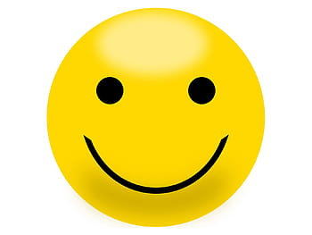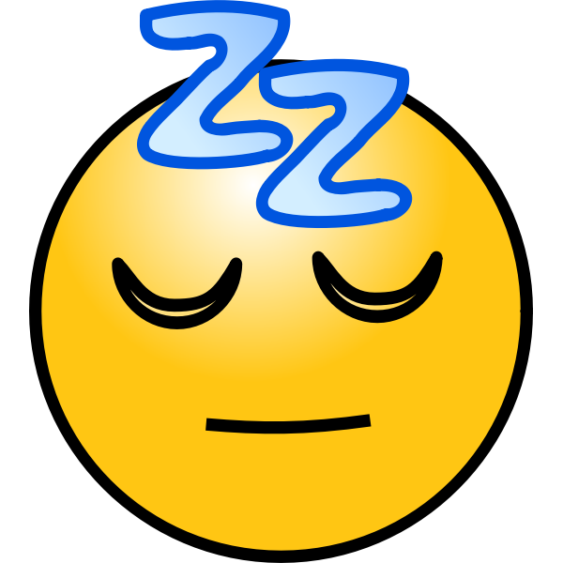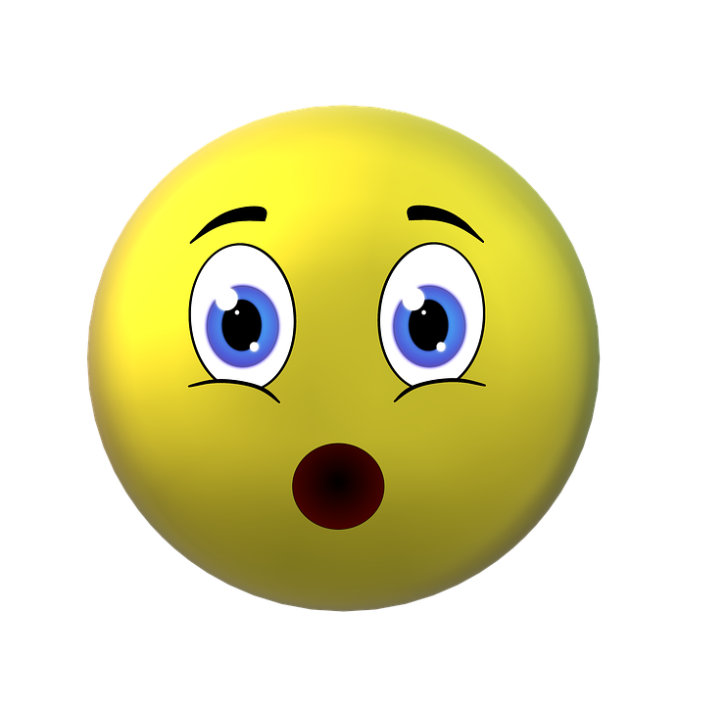
Sunday
Monday
Tuesday
Wednesday
Thursday
Friday
Saturday

What I thought about my reading this week (one paragraph -- type it into the box below):
- What interested, surprised, or confused you most about your reading this week? Why?
- Or, How does something you read this week connect to your life or the world around you?

Weekly Log for Week of July 5 - July 11

What I read this week:
Day | Title | Author and Genre | Pages | Choose an Emoji
Sunday
Monday
Tuesday
Wednesday
Thursday
Friday
Saturday

What I thought about my reading this week (one paragraph -- type it into the box below):
- What interested, surprised, or confused you most about your reading this week? Why?
- Or, How does something you read this week connect to your life or the world around you?
Weekly Log for Week of July 12 - July 18
What I read this week:
Day | Title | Author and Genre | Pages | Choose an Emoji
Sunday
Monday
Tuesday
Wednesday
Thursday
Friday
Saturday

What I thought about my reading this week (one paragraph -- type it into the box below):
- What interested, surprised, or confused you most about your reading this week? Why?
- Or, How does something you read this week connect to your life or the world around you?

Weekly Log for Week of July 19 - July 25
What I read this week:
Day | Title | Author and Genre | Pages | Choose an Emoji
Sunday
Monday
Tuesday
Wednesday
Thursday
Friday
Saturday

What I thought about my reading this week (one paragraph -- type it into the box below):
- What interested, surprised, or confused you most about your reading this week? Why?
- Or, How does something you read this week connect to your life or the world around you?

Weekly Log for Week of July 26 – August 1
What I read this week:
Day | Title | Author and Genre | Pages | Choose an Emoji
Sunday
Monday
Tuesday
Wednesday
Thursday
Friday
Saturday

What I thought about my reading this week (one paragraph -- type it into the box below):
- What interested, surprised, or confused you most about your reading this week? Why?
- Or, How does something you read this week connect to your life or the world around you?

Weekly Log for Week of August 2 – August 8

What I read this week:
Day | Title | Author and Genre | Pages | Choose an Emoji
Sunday
Monday
Tuesday
Wednesday
Thursday
Friday
Saturday

What I thought about my reading this week (one paragraph):
- What interested, surprised, or confused you most about your reading this week? Why?
- Or, How does something you read this week connect to your life or the world around you?

Weekly Log for Week of August 9 – August 15

What I read this week:
Day | Title | Author and Genre | Pages | Choose an Emoji
Sunday
Monday
Tuesday
Wednesday
Thursday
Friday
Saturday

What I thought about my reading this week (one paragraph -- type it into the box below):
- What interested, surprised, or confused you most about your reading this week? Why?
- Or, How does something you read this week connect to your life or the world around you?

Weekly Log for Week of August 16 – August 22

What I read this week:
Day | Title | Author and Genre | Pages | Choose an Emoji
Sunday
Monday
Tuesday
Wednesday
Thursday
Friday
Saturday

What I thought about my reading this week (one paragraph -- type it into the box below):
- What interested, surprised, or confused you most about your reading this week? Why?
- Or, How does something you read this week connect to your life or the world around you?

Weekly Log for Week of August 23 – August 29
What I read this week:
Day | Title | Author and Genre | Pages | Choose an Emoji
Sunday
Monday
Tuesday
Wednesday
Thursday
Friday
Saturday

What I thought about my reading this week (one paragraph -- type it into the box below):
- What interested, surprised, or confused you most about your reading this week? Why?
- Or, How does something you read this week connect to your life or the world around you?
Weekly Log for Week of August 30 – Sept 5

What I read this week:
Day | Title | Author and Genre | Pages | Choose an Emoji
Sunday
Monday
Tuesday
Wednesday
Thursday
Friday
Saturday

What I thought about my reading this week (one paragraph -- type it into the box below):
- What interested, surprised, or confused you most about your reading this week? Why?
- Or, How does something you read this week connect to your life or the world around you?

Weekly Log for Week of Sept 6 – Sept 12

What I read this week:
Day | Title | Author and Genre | Pages | Choose an Emoji
Sunday
Monday
Tuesday
Wednesday
Thursday
Friday
Saturday

This summer, I read:
Total Number of Minutes
Total Number of Days
Total Number of Books

LETTER ABOUT A BOOK or TEXT

Directions: Choose something you read over the summer and write a letter to your teacher or classmates about why it is an important book or collection of texts to read.

In your letter, be sure to:
- Include the title, author, and a brief summary of the book or text
- Provide reasons and evidence for why the book or collection of texts is important to read (consider character decisions, conflict/s in the book, connections to your life or the world, themes & lessons, etc.)

Begin typing here:

Family Tips for Supporting your Middle School Reader

Reading is a really important habit for all kinds of people – and especially for middle school students. Reading for 30 minutes a day is probably the most important academic habit a child can develop to prepare for high school and college. Students learn new words, get faster, learn about the world, have interesting things to talk about all the time, and (we hope) have fun! Summer reading is especially important because it helps students maintain the progress they’ve made the previous year in school. Our brain is like a muscle; if you don’t use it, you lose it. If libraries remain closed, encourage your child to visit the library online. You can visit NYPL.org, BrooklynLibrary.org, or QueensLibrary.org.

Here are some tips for families to Promote Reading at Home Grades 6 - 8 – adapted from NYC Reads 365:
Model positive reading habits
- Let your children see you read for pleasure.
- Share your excitement for reading with your kids. Talk about what you are reading and why you’re reading it.
- Give books as presents for holidays or as rewards for special accomplishments.
Make reading part of regular family activities
- Schedule time into your daily/weekly schedule for the whole family to sit down and read.
- Take a trip to the local bookstore, or an online bookstore, and shop for books as a family.
- Visit the library or online library as a family; help each other select books to read.
- Attend virtual readings or watch videos of favorite authors.
- Encourage older children to read to younger children (siblings, cousins, neighbors, etc.).
- At meal time, or other informal times, ask your children about the book they are reading.
- Use reading questions to have deeper conversations about books.
- Share your childhood memories about reading and books. Talk about your own favorite books and authors from middle school, your struggles/successes with reading, etc.
Read aloud to each other
- Ask your child to read his/her book aloud to you. If they seem resistant, ask them to read a smaller section such as a paragraph, or page from their book.
- Read aloud interesting articles from newspapers, magazines, or online sites. “Listen to this, the Mayor thinks we should....”
- Incorporate these read alouds into your daily/weekly routines.
- Read aloud an instruction manual or recipe, or ask your child to read it aloud to you.
Create a reading environment in your home
- Set up a comfortable space in your home for reading. Placing pillows or cushions on the floor is an easy way to make your regular space into a reading space.
- Have reading materials (books, magazines, newspapers, etc.) throughout your home and easily accessible to your children.
- Subscribe to a magazine and have the magazine sent directly to your child or register for an online subscription. Some popular magazines include: Sports Illustrated for Kids, National Geographic Junior, National Geographic, J-14, GL, Boys’ Life, Discovery Girls, Latina, Latinitas (online), Newsweek, Time, Time for Kids, J-14, and Muse.
- Use reading as a vehicle for learning. Research and read about topics that come up naturally in conversation. (“I wonder when the subway was built—let’s look it up.”)
- Ask relatives and friends that don’t live near you to send letters or emails to your child.
- Set aside a span of time every night that is just for reading (turn the phone and TV off).
- Make a schedule with your child to help plan out when reading can be done.

SUMMER READING – FAMILY EMAIL
June 2020

Dear Parents/Guardians:

Please review the attached materials about expectations for your child’s summer reading, including “Tips for Supporting Your Middle School Reader During the Summer.”

To help your child continue to make reading progress, it is critical for your child to read every day. At minimum, your child should be reading at home for at least 30 minutes each day or 2hrs and 30min each week throughout the summer months.

Students (and families) have access to free online books through the public library system. You can find more information on these websites: New York Public Library, BrooklynLibrary.org, or QueensLibrary.org

Thank you for your collaboration and partnership throughout this year. We are excited to continue our work together as your child steps up into the next grade.

Sincerely,

The Literacy Team at the Brooklyn Green School

