Lincoln Avenue PTA 2021-2022

President Corinne Ventola corinneventola@gmail.com
VP Activities Emily Castillo emilymcastillo@gmail.com
VP Fundraising Danielle Conway dconway917@gmail.com
Treasurer Lauren Fregonese lfregonese@gmail.com
Recording Secretary Marcie Cuevas mcuevas828@icloud.com
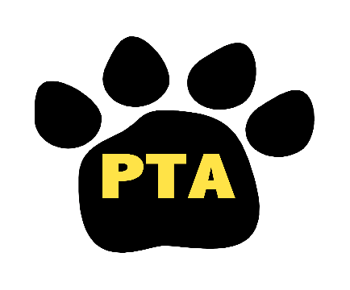

Lincoln Ave PTA – (Monday, 9/12/22)

Formal
- Meeting called to order
- Pledge of Allegiance
- Principal’s Report from Mrs. Cool
- Treasurer’s Report
  - Discussed prior year’s expenses being put towards the new playground
  - Instructions on using the income and expense form
- PAC Report

Old Business
- School Supplies Sale Update
  - All boxes were delivered to students accordingly!
- Welcome Back Sign
  - Students and staff enjoyed their huge greeting upon their first day arrival
- PTA Tea
  - 9am on the first day of school. Great opportunity for folks to sign up for committees and meet new members of the Lincoln community.
- Ice Cream Truck
  - Arranged for the whole school on Friday, Sept. 9.
- Teachers Welcome Back Breakfast
  - A spread for the staff from Zimi’s was served with much appreciation.

New Business
- School pictures 9/13 with retakes 11/7
- Family BBQ
  - BBQ food will be served, sports gamed will be facilitated from an outside vendor, chalk and bubble will be supplied. Drinks and snacks will be sold.
- Miss Chocolate Fundraiser
  - Starts in October – online sales only.
- Fall Festival
  - Incorporating the door tour, trunk or treat and food on October 26.
- Amazon Smile link
  - Link your Amazon account to our PTA name so the PTA gets a percent of sales.
- Committee Sign-ups
  - Curriculum Advisory Council
  - #SELFIE Committee
    - Staff, students, parents (socio/emotional learning on 9/28 at the Central office)
- Class Parent Volunteers
Fundraising
- PTA Membership drive is ongoing through September - Join now!!! $10 per member.
- Amazon Smile runs all year! Please use Smile when shopping online this holiday season!
- Spiritwear sale is ongoing
  - Adding more products seasonally!

Next PTA Meeting will be 11/7/22 at 7pm

