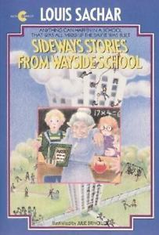
Mrs. Amy Ellington
Sideways Stories from Wayside School
By: Louis Sachar

I LOVE this book. I read it several times. It is a very funny book. It is based on a. "Wayside School was actually built sideways," he says. It was supposed to be one story high, with thirty classrooms in a row. Instead it is thirty stories high, with one classroom on each story. This book turns everything sideways. In the book, there were 30 stories about the children and teachers at Wayside School. One of the characters that I remember the most was Mrs. Gorf. She was the teacher in the classroom on the thirtieth story of Wayside School. She likes to turn children into apples by wiggling her ears and sticking out her tongue: "Mrs. Gorf didn't like children, but she loved apples"

