School for Global Leaders’
Virtual School Tours

SGL IS BECOMING A Prestigious International Baccalaureate School

School for Global Leaders | 145 Stanton Street | NY, NY 10002
Sign-up for a tour on our website: www.sgl378.org [Go to AROUND SGL > SCHOOL TOURS]

Dates
November 24, 2020: 10am | December 1, 2020: 5:45pm | December 8, 2020: 10am December 15, 2020: 5:45pm | December 22, 2020: 10am

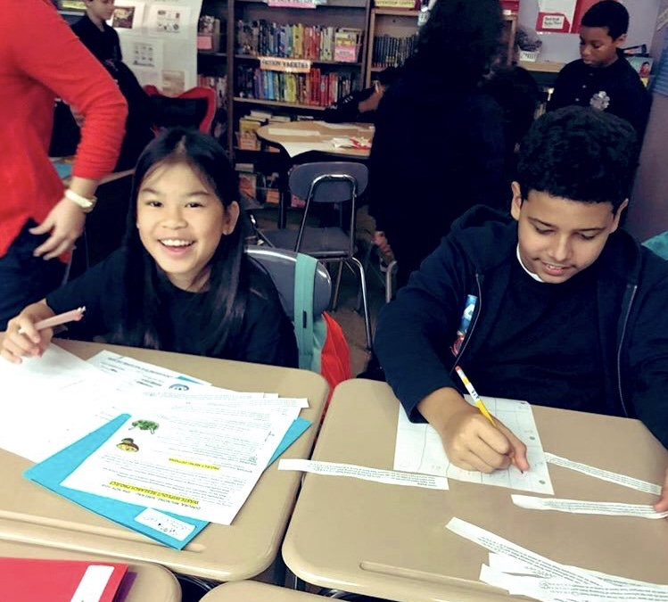 | 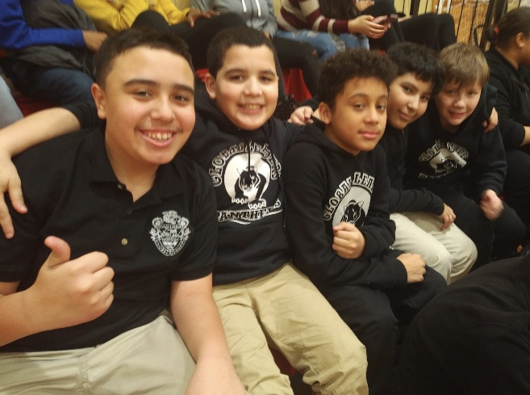 | 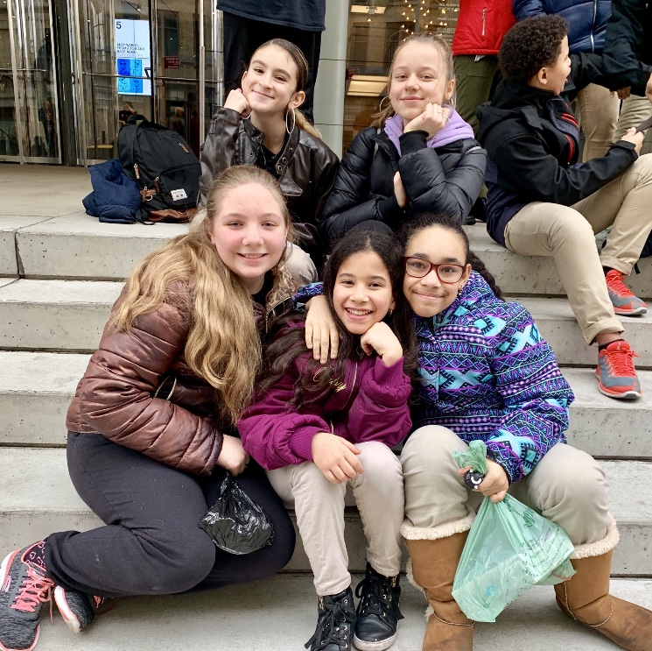

Learn about our:

- International Baccalaureate Program

- Supportive and Mindful Classrooms

- Collaborative Problem Solving, Research and Inquiry

- Lincoln Center Education Partnership

- Yale Center for Emotional Intelligence and Restorative Circles programs

- Student Leadership Opportunities

- Project-Based Learning & Community Building

- Commitment to Healthy Play with Daily Recess, Weight Training, Dance and Physical Education

- Varied Elective Classes including Advanced Art Portfolios, Chorus, Culinary Class, Theatre, Environmental Explorers and more!

- Comprehensive Sports Program

- Dual Language Mandarin Program

Learn to change the world!

