First Grade Supply List – 2019/2020

5 plastic folders with pockets on the bottom  1 yellow, 1 red, 1 orange, 1 blue 1 green | 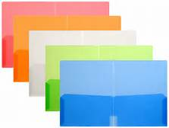
2 packs of 3x3 Post It Notes
24 sharpened pencils | 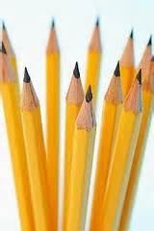
1 child scissor | 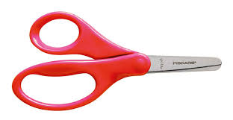
4 Large glue sticks | 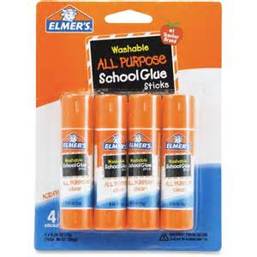
Lysol Disinfecting Wipes  MUST BE LYSOL BRAND NOT CLOROX | 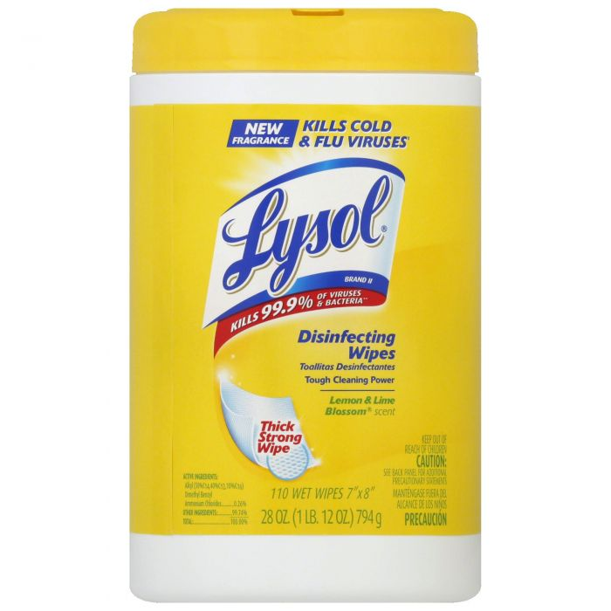
1 soft pencil case  (NOT PLASTIC) | 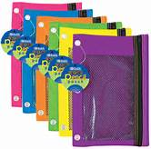
4 marble composition books wide ruled | 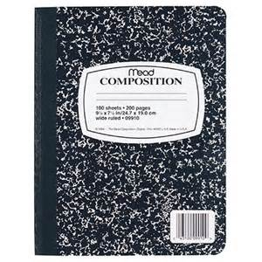
2 packs of 4 BLACK DRY ERASE Fine Point | 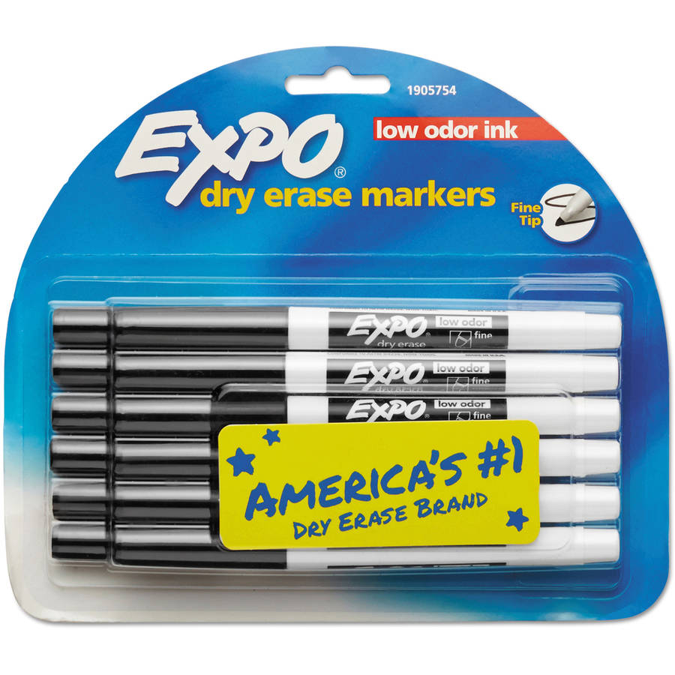
3 boxes of 24 Crayola crayons | 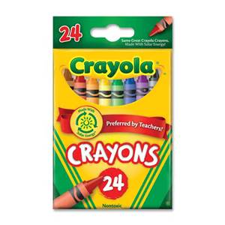
1 boxes of Crayola markers | 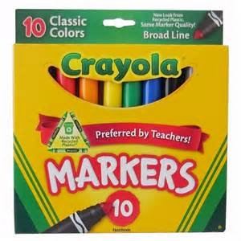
3 boxes of tissues | 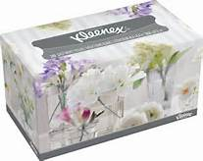
1 Computer Headphone -over the head type | 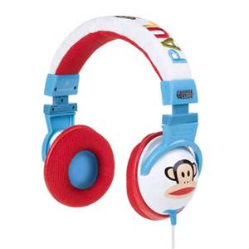
1 box of gallon sized zip-lock bags | 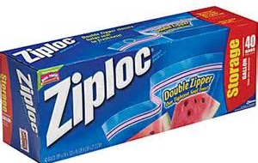
1 box of sandwich sized zip-lock bags | 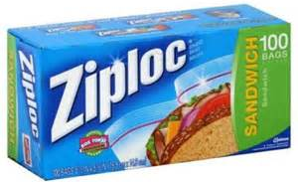
$ 15 for in class subscriptions

