BREAKFAST/LUNCH BARNWELL WARHORSE CAFÉ MENU SEPTEMBER 2018

MONDAY | TUESDAY | WEDNESDAY | THURSDAY | FRIDAY
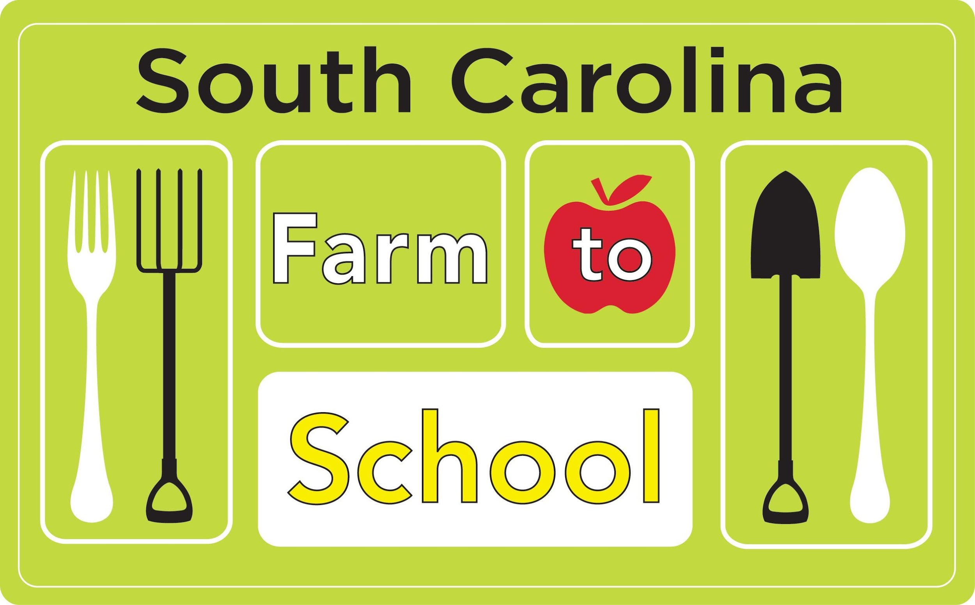 | **MENU SUBJECT TO CHANGE***  ****Chef Salad (High and Middle) Choice SERVED AS A SECOND ENTRE’ CHOICE TUES, WED, THURS*****  **Use Slushy Daily for extra fruit (Middle and High) **  ****P&J Sandwich (ELEM SCHOOL) Choice SERVED AS A SECOND ENTRE’ CHOICE TUES, WED, THURS****  ****MILK CHOICE SERVED DAILY WITH BREAKFAST AND LUNCH****
3  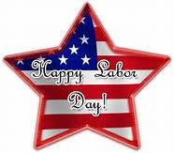 | 4  Salisbury Steak  Baked Potato/Sour Cream  Carrots  Black Beans  Roll  Pears  Apple  BRK:  Blueberry Pancake  Fruit (Halo Orange) | 5  Smoked Sausage  Cabbage  Rice and Tomato  Green Beans  Wheat Roll  Banana  Fresh Grapes  BRK:  Sausage Biscuit  Juice/Raisins | 6  Spaghetti  Whole Wheat Cracker  (2 packs.)  Yellow Squash  Romaine Salad Mix  Strawberries  Fruit Punch Juice  BRK:  Banana Bread  Fruit (Plum) | 7  Chick Fil A or  Fish Filet on Wheat Bun  Lettuce, Tomato, Pickles  California Blend  Potato Tots  Apple Juice  Peaches  BRK:  Sausage, Egg & Cheese Burrito  Fruit (Banana)
10  Beef-A-Roni or  Tuna Salad Sandwich  Tossed Salad  Green Beans  Pineapple tidbits  Grape Juice  BRK:  Strawberry Pop Tart  Fruit (Apple) | 11  Chicken Fajita  Red Peppers Green Peppers, Onions, Salsa  French Fries  Refried Beans  Oranges  Fruit Salad  BRK:  Yogurt & Graham Crackers  Juice/Raisins | 12  Meatball Sub  Vegetable Blend  Sweet Potato Patty  Apple Cobbler  Grapes  BRK:  Cinnamon French Toast  Fruit (Banana) | 13  BBQ Pork  Brown Rice  Stewed Tomatoes  Broccoli & Cheese  Corn Bread  Peaches  Banana  BRK:  Blueberry Waffle  Juice/Raisins | 14  Pizza Choice  Corn  Potato Wedges  Applesauce  Cranberry Juice  BRK:  Pancake Pup  Fruit (Pineapple Chuck)
17  Hamburger or Cheeseburger on a Wheat Bun  Lettuce, Tomato, Pickle  Sliced Carrots  Fries  Grape Juice  BRK:  Banana Muffin  Fruit (Plum) | 18  Chicken Fajita / Turkey Wrap  Lettuce, Tomato, Pickle  Sweet Potato Fries  Corn on the Cob  Spiced Apples  Fruit Cocktail  BRK:  Maple Waffle  Juice/Raisins | 19  Country Fried Steak  Macaroni & Cheese  Green Beans  Carrots  Raisins  Pineapple  BRK:  Cherry Strudel  Fruit (Banana) | 20  Baked Chicken  Brown Rice & Gravy  Black Eyed Peas  Collard Greens  Biscuit  Fruit Punch Juice  Apple  BRK:  Zucchini Bread  Fruit cup | 21  Fish Nuggets or  Popcorn Chicken  Garlic Mashed Potatoes  Roll  Veggie Cup  Diced Pears  Banana  BRK:  Sausage Biscuit  Juice/Raisins
24  Taco Salad w/Chips or  Grilled Chicken Sandwich  Lettuce, Tomato, Cheese  Refried Beans  Cinnamon Roll  Peach Cup  Apple Juice  BRK:  Blueberry Pop Tart  Fruit (Pineapple Chuck) | 25  Chicken Alfredo  Egg Noodles  White Roasted Potatoes  Sweet Peas  Roll  Fruit Cocktail  Orange Slices  BRK:  Mini Cinni  Juice/Raisins | 26  Meatloaf  Wheat Roll  Baby Carrots  Mashed Potatoes  Red Grapes  Peaches Cobbler  Slice Red Apple BRK:  Triple Berry French Toast  Fruit cup | 27  Chicken Tenders  Mustard Greens  Brown Rice & Gravy  Succotash  Strawberries  Grape Juice  BRK:  Apple Strudel  Fruit (Banana) | 28  Rib A Que / BBQ Chicken on a Bun  French Fries  Italian Green Beans  Applesauce  Banana  BRK:  Pizza Bagel  Juice/Raisins

Barnwell School District 45 is an equal opportunity provider and employer.

