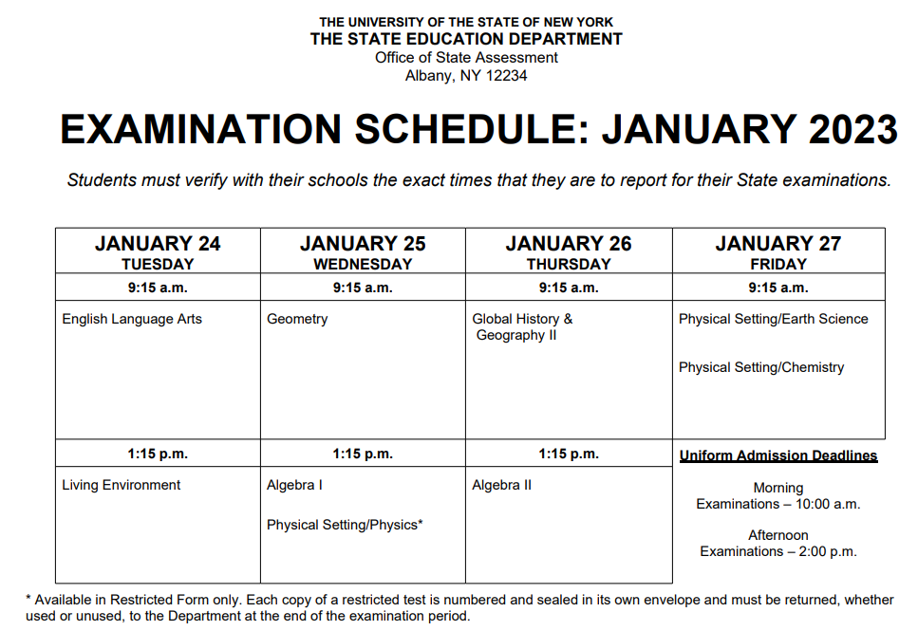

* **FOR MORNING EXAMS: STUDENTS REPORT AT 8:15 A.M.**
* **FOR AFTERNOON EXAMS: STUDENTS REPORT AT 12:15 P.M.**