Delone Catholic High School

Delonian

2018-19 Yearbook Order Form

Thank you for ordering a 2018-19 Delonian. The cost for the yearbook is $79 or $85 with a name imprint. Orders MUST be received by Mar. 11, 2019 to guarantee a yearbook. Yearbooks can also be purchased on-line using Herff Jone’s website www.YearbookOrderCenter.com and selecting Delone Catholic or using order number 4186.

Remember, all students are welcome to sell $400 worth of ads to order a FREE yearbook, and forms can be found in the Main Office or by seeing Miss Sneeringer in Room 18. Additionally, to download the advertising form or this order form, go to www.delonecatholic.org and click on About DCHS ->Directory ->Group Directory

Name:
Home Phone: |  |  |  |  |  | or |  | Cell Phone:
I am ordering this yearbook for:
(Please use an additional form for each student)
Name as it is to appear imprinted on the yearbook (if applicable):
The recipient of this yearbook is currently a: |  |  |  |  | Senior |  |  |  | Junior |  |  |  | Sophomore |  | Freshman
Student ID Number: |  |  |  |  |  |  |  | Homeroom:

Please make checks payable to Delone Catholic High School. This order form may be returned with payment to the Main Office in person or by mail at the following address:

ATTN: Miss Beth Sneeringer, Delonian Business Manager
140 South Oxford Avenue
McSherrystown, PA 17344

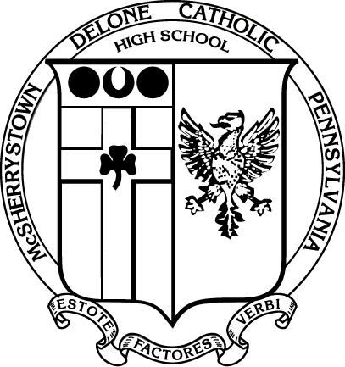

__________________________________________________________________________________________________________________________________
(for Business Manager use)

Date Deposited: |  | Check Number: |  | Cash:

