Lincoln Avenue PTA 2021-2022

President Corinne Ventola corinneventola@gmail.com
VP Activities Emily Castillo emilymcastillo@gmail.com
VP Fundraising Danielle Conway dconway917@gmail.com
Treasurer Lauren Fregonese lfregonese@gmail.com
Recording Secretary Marcie Cuevas mcuevas828@icloud.com
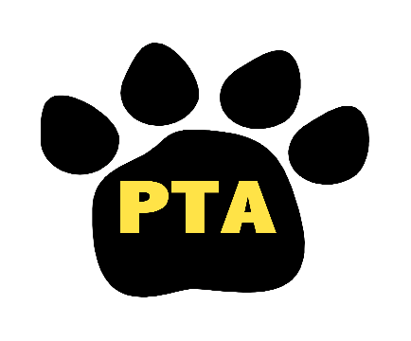

Lincoln Ave PTA – (Monday, 11/14/22)

Formal
- Meeting called to order
- Pledge of Allegiance
- Approve minutes from September meeting
- Principal’s Report from Mrs. Cool
- Treasurer’s Report
- Vote on By Laws
- PAC Report
  - High School
    - Movie Night
    - Money Raffle
- Middle School
      - Holiday Boutique 11/30
  - Franklin
      - Family BINGO on 11/4
  - Lincoln
      - Thanksgiving Feast 11/23
      - Thanksgiving Craft 11/22
  - Evans
      - Thanksgiving Feast 11/22

Old Business
- School pictures retakes 11/7
- Family BBQ
  - Fun event for families.
  - Backyard PE activity for the children
  - May change some things about this event for next year
- Miss Chocolate Fundraiser
  - Brought in over $4k
- Fall Festival
  - Huge success for the PTA.
  - Incorporated the Trunk or Treat.
  - Photo booth was added

New Business
- Murder Mystery Dinner
  - Had to cancel. Refunds available. Redo is March 10, 2023.
- Thanksgiving Feast and Craft
  - On 23rd – looking for more volunteers. Craft is on the 22nd for each grade.
- Great American Cookie Kit
  - Flyer will go out shortly. DIY cookie kits for the holidays.
- Holiday Shop
  - 12/8. Seeking volunteers via ParentSquare. $2.00 per item. Information will go out.
- Parents Night Out- Kids Craft
- Book Fair
  - Set to be Jan 23.
- Art in Park June 3 art in park committee
  - Looking for parent volunteers to help cut and paint cardboard that the students artwork will get posted on. And then getting applied on the cardboard.
  - For entire school district.
Fundraising
- Amazon Smile runs all year! Please use Smile when shopping online this holiday season!
  - Will send out instructions to make sure it is done correctly.
- Spiritwear sale is ongoing
  - Added new items for the holidays!

Next PTA Meeting will be 1/23/2023 Virtual

