Mrs. Elizabeth Davis
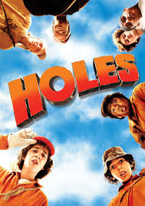
HOLES
Have you even felt like you were in the wrong place at the wrong time? Well, Stanley Yelnats knows all too well the consequences of being EXACTLY where he shouldn’t have been at PRECISELY the wrong time. His unfortunate luck lands him in a youth detention center digging… you guessed it, HOLES. The plot thickens when he meets a boy named Zero. They discover the history of the camp and unravel a mystery after mystery. Do the boys successfully end the series of unfortunate events that have fallen upon the Yelnats family? Pick up a copy and dig into a copy of HOLES to find out.

