PS 396
BURNSIDE BEATS
Issue #11, January 2020
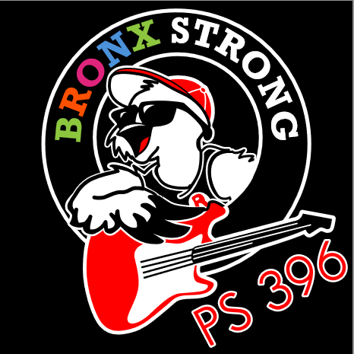
Happy ROCKIN’ NewYear!
2020
A Message from our Principal, Nicole A. Tiné…
Happy New Year and Welcome Back Families! We have had a fantastic first four months of school and we are looking forward to the rest of the year. A new year always gives us the opportunity to reflect upon what we have done well and what we can do better. Have you been trying to figure out a new year’s resolution? If the answer is yes, I have a great suggestion for you. How about working to help your children have greater school success in 2020? Here are a few ideas to ensure your child is successful at PS 396.  1. Monitor your children’s schoolwork. One way to do this is to have them check in with you after school and share how their day went. A good opening question to help them communicate about this is to ask, “What did you learn in school today?” Check their backpacks every night and discuss any school papers that are brought home. You can further monitor by checking on your child’s homework when they have completed it. While parents should never do homework for their children, it is sound practice to help them |  | if they are struggling.  2. Make sure your children get to school and on time. Children cannot learn if they are not in school. The more students are in school, the higher their achievement. In addition, poor attendance causes students to get behind in their learning and catching up can be very difficult when they return. Being late causes a disruption not only to your child, but also to all of the children in the class. PLEASE make sure your children are walking in our doors by 8:00am every day.  3. Reward your children’s efforts for trying their best. Rewarding students for high grades is not as effective as rewarding them for their effort. Children want to make their families proud. The best way to motivate effort is to notice it, praise it, and reward it.  4. Discuss with your child how important it is in earning a degree |  | higher than high school. Although your children are only in elementary school, this should start at a young age. For students to be successful in today’s world, it takes more than a high school diploma. In the 21st century, almost all students need a college degree. Having students set higher education, as a target early in their lives will help them set ambitious goals for their academic progress as they proceed through school.  5. Finally, be involved! How important is parent involvement in their children’s education? Tremendous! Study after study shows that it may be the top factor leading to student success. We are committed here at PS 396 to a partnership with all of our families. By working together, we can make a difference!  I am very proud of the children, families, teachers and staff at PS 396 and I look forward to a ROCKIN’ 2020!
Check us out on the web:  www.PS396.org  Follow us on Twitter:  @PS396BX |  |  |  |  | Join us!  January 23rd  Dads bring your kids to school and join us for ROCKIN’ Role Models & a Bro Breakfast  7:45am – 8:45am

What’s Your ROCKIN’ Resolution?

RESPECT, OWNERSHIP, CURIOSITY, KINDNESS, INTEGRITY, & NEVER GIVING UP = Our ROCKIN’ Values
Here are some ROCKIN’ New Year’s Resolution ideas for your kids:
- I will eat more go foods and less slow foods.
- I will go to bed in time to get at least 8 full hours of sleep each night.
- I will do my homework before anything else after school.
- I will be kinder to my friends at school.
- I will read more books and watch less TV.
- I will visit the public library with a parent or friend.
- I will try to talk to a parent or a trusted adult when I have a problem or feel stressed.
- I promise to do my best to be safe and follow school rules.
- I will always try to make good choices at school and at home.
- I will be my BEST self!

January Interim Progress Reports

All students in grades K-5 will receive an Interim Progress Report at the end of January documenting their progress thus far this school year. This report will indicate if your child is meeting or exceeding grade level standards and therefore on track to be promoted to the next grade or if they are below grade level standards and in jeopardy of being left back. Our next formal Parent Teacher Conferences are scheduled for March however, we encourage you to review this report with your child and schedule a teacher meeting if you have any concerns regarding your child’s growth.

