PS 396
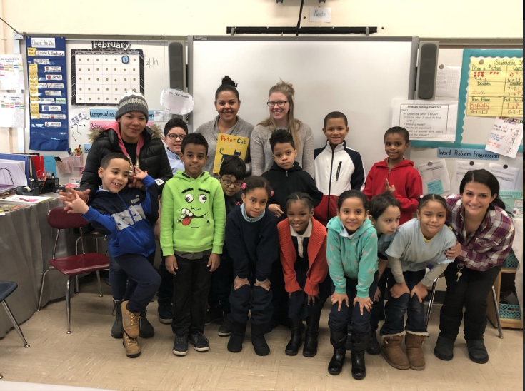
BURNSIDE BEATS
Issue #3, March 2019
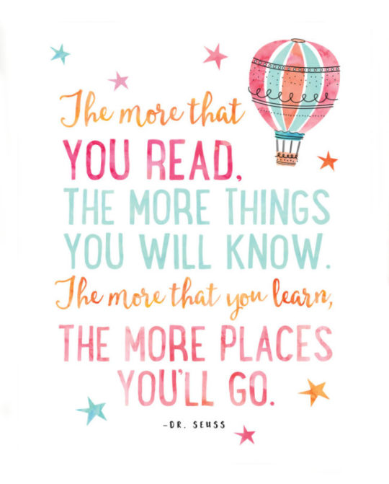

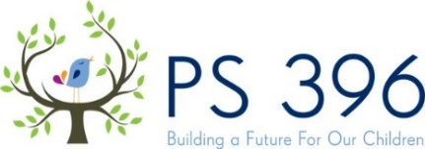
Building Our Culture
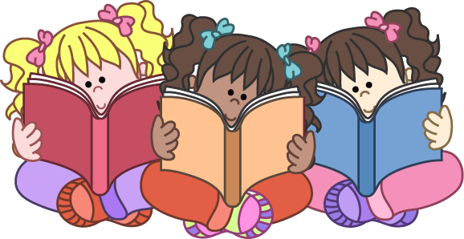 of Reading 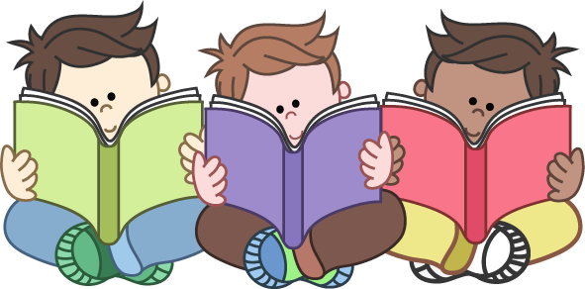

World Read Aloud Day with Class 202

A Message from our Principal, Nicole A. Tiné…

A child's reading skills are critically important to their success in school as they will allow them to access the breadth of the curriculum and improve their communication and language skills. In addition, reading can be a fun and imaginative time for children, which opens doors to all kinds of new worlds for them.
With busy schedules and lots to teach, teachers struggle to find time each day to listen to their children read and have them read independently as much as they would like.
Studies show that reading for pleasure makes a big difference to children’s educational performance. Likewise, evidence suggests that children who read for enjoyment every day not only perform better in reading tests than those who do not, but also develop a broader vocabulary, increased general knowledge and a better understanding of other cultures. In fact, reading for pleasure is more likely to determine whether a child does well at school than their social or economic background.
Parents can make a huge difference! Parents are the most important educators in a child’s life – more important than their teachers – and it is never too late to start reading together.
Learning to read is about listening and understanding, as well as working out what is printed on the page. Through hearing stories, children are exposed to a wide range of words. This helps them build their own vocabulary and improve their understanding when they listen, which is vital as they start to read. It is important for them to understand how stories work too. Even if your child does not understand every word, they will hear new sounds, words and phrases which they can then try out, copying what they have heard.
Whether your child is only just beginning to learn to read or whether they are fluent, you can play an important role in helping to keep them interested in books. Find out what interests them, help them to find books that will be engaging and fun, and spend time reading the books they bring home from school together

Check us out on the web: www.PS396.org |  | 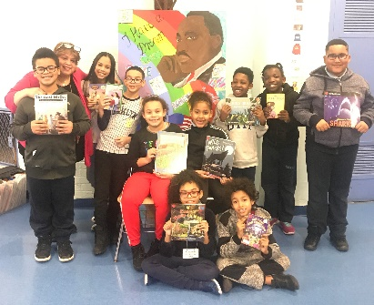  Meet the PS 396 Library Assistants  Our Library Assistants are students in grades 3-5 selected after they wrote essays about the importance of our school library. They earn ROCKIN dollars by working with Dr. Camacho one period a week during their recess to organize library books, return books to shelves, maintain the neatness of the library, help students select books, create and distribute late book notices and help create library bulletin boards. They continue to do a great job!  From left to right… Justice Enrique,  Dr. Camacho, Isabella Cabral, Christian Urena, Lara Fleary, Yelenny Ramirez, Idris Sisoho, Mia Little, Matthew Garcia, Bottom front: Dylan Williams, Leandro Saldana

ROCKIN’ A BOOK

RESPECT, OWNERSHIP, CURIOSITY, KINDNESS, INTEGRITY, & NEVER GIVING UP = Our ROCKIN’ Values  R- Respect the books you borrow from public, school and classroom libraries.  O- Show Ownership as you record and write about all of the books you have read; onto your school reading logs.  C- Display Curiosity as you dive into a new book and ask questions, and jot down important facts along the way. | K- Exhibit Kindness as you share a book review on a recent book you read or read to someone else.  I- Display Integrity by reading as many books as possible, even when your teachers or family members are not watching you read.  N- Never Give Up as you persevere reading through a challenging fiction or non-fiction book.  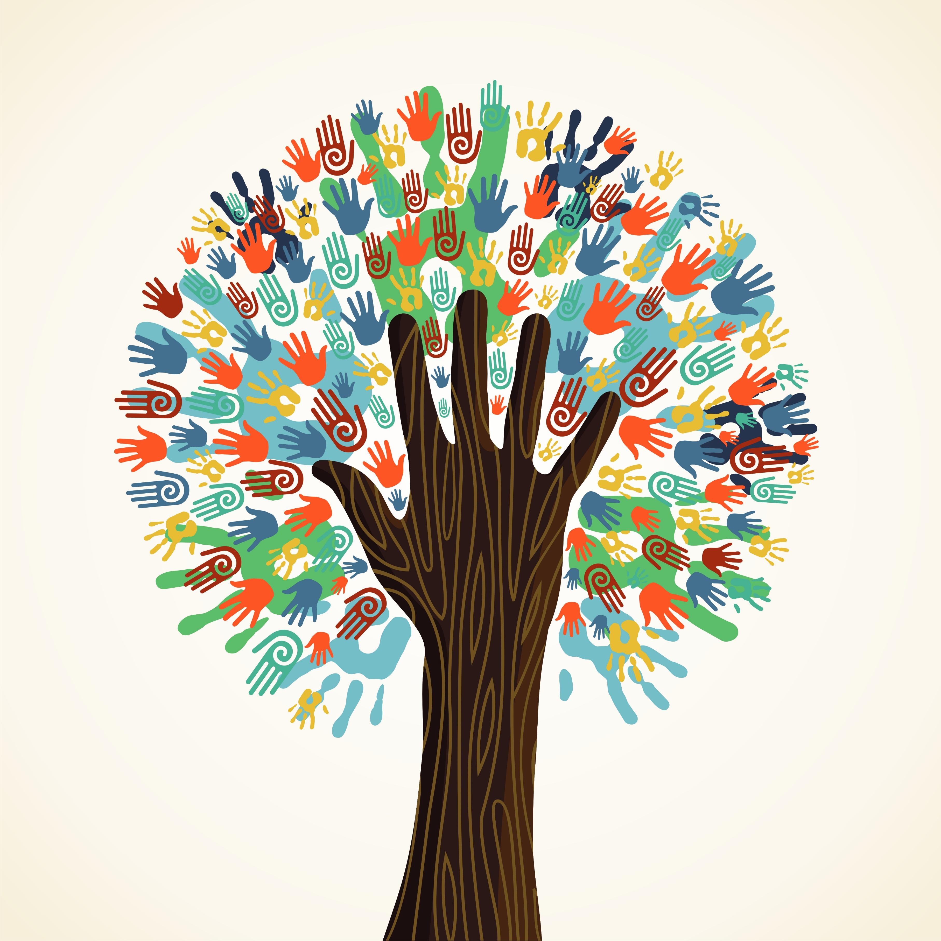
Winning Doors
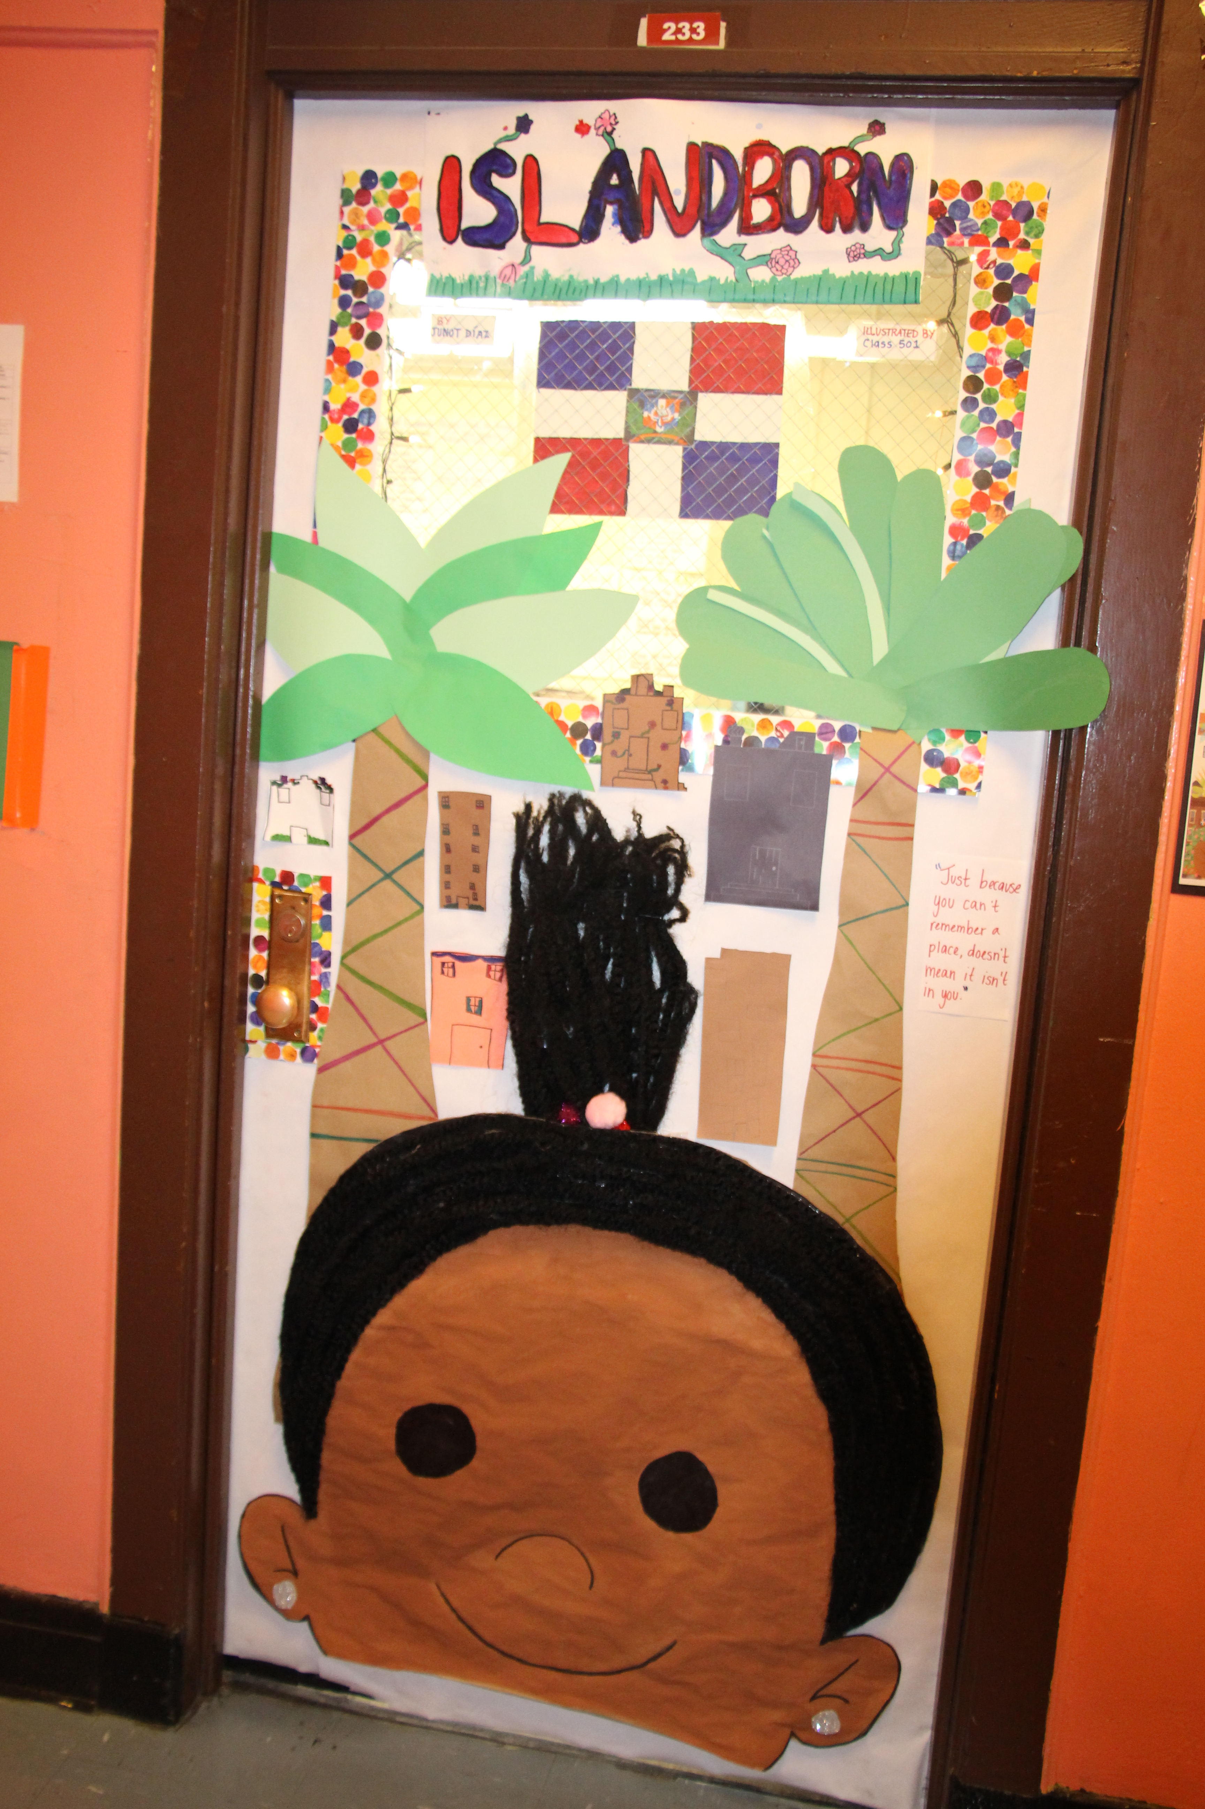
Class 501
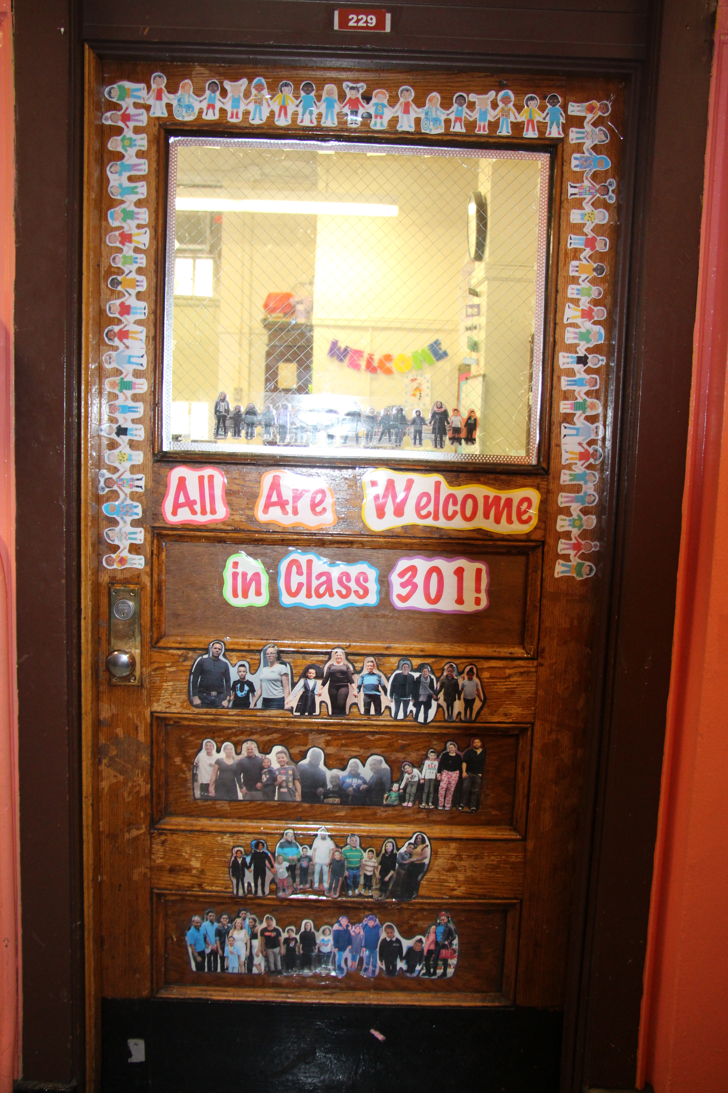
Class 301

Celebrating Reading & Writing at 396

- On Tuesday, January 29th, we invited parents to join us for a Multicultural Literacy celebration. Teachers shared books that represented various cultures around the world and celebrated their students’ backgrounds. Parent and students learned about reading strategies to implement at home, voted in the school’s classroom door decorating contest, enjoyed a musical performance of “One Love,” and took home a bag of books to support at home reading.
- Every year, on World Read Aloud Day, people all around the globe read aloud together and share stories to advocate for literacy as a human right that belongs to all people. I just wanted to thank you so much for taking time out of your busy day to read to your child’s classroom during our World Read Aloud Day Celebration on Friday, February 1, 2019. Having our parents come in and share stories truly helps us build our culture of reading.
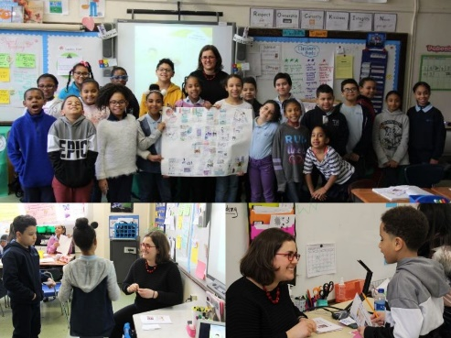
- For the past three years PS 396 has participated in the Writers in Schools program, a partnership with Lambda Literary and the NYC Department of to bring award-winning LGBTQ writers into schools to discuss their books and lives. This year our 3rd and 4th graders are participating in this wonderful program that promotes acceptance and understanding. Our 4th graders had their author visit on February 11th with Miriam Schiffer, author of “Stella Brings the Family.” Miriam did a wonderful job sharing her book, answering questions from our students and challenging their thinking. It was a great day!

