PS 396
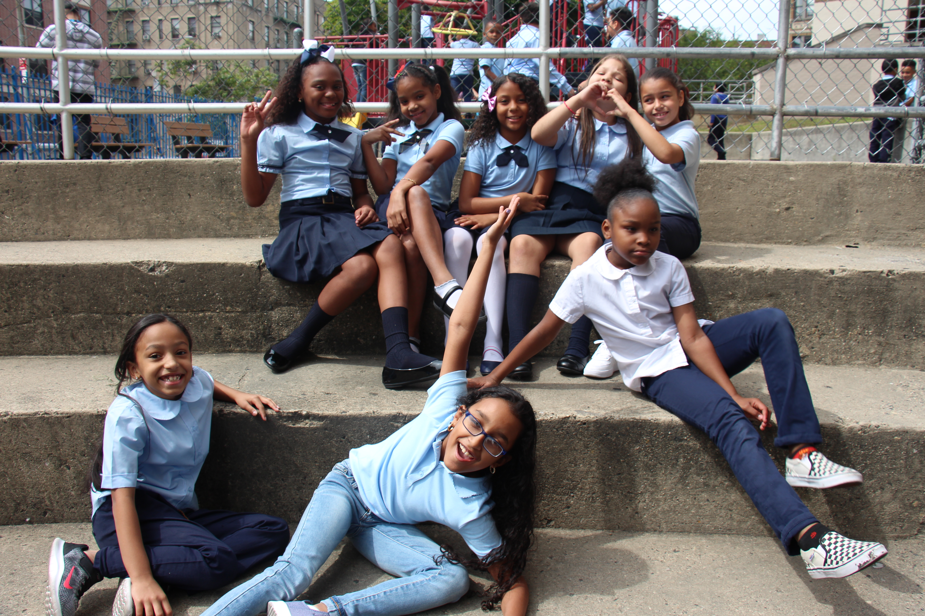
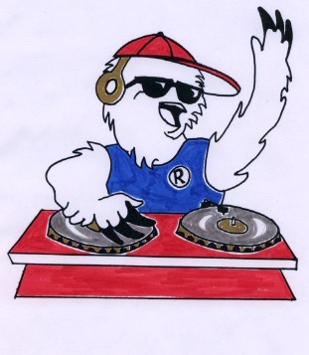
BURNSIDE BEATS
Issue #8, October 2019
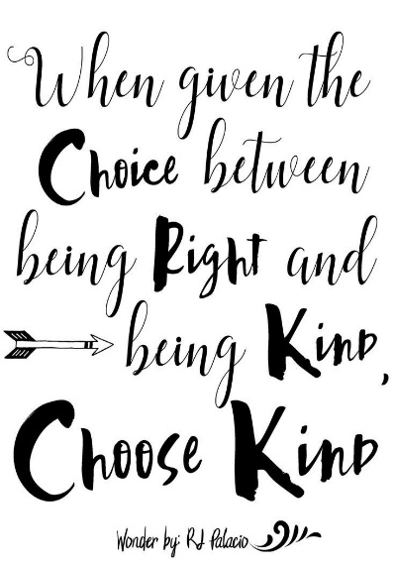
4th Graders at Recess

The Power of Kindness
A Message from our Principal, Nicole A. Tiné…

Kindness is a simple concept, yet so very impactful. It has the power to improve our own well-being as well as that of our families, friends, acquaintances, and even complete strangers. The very act of expressing kindness to one another can make us more understanding of other people’s hardships. Within the workforce, kindness towards one another can inspire staff to be more productive and within our communities, kindness contributes to safer and cleaner schools and neighborhoods.

Wow, can kindness really do all that? The simple answer is YES! Pay attention to how kindness affects your life. Think about those moments when someone does something unexpectedly kind for you. How frequently does it happen? How does it make you feel? Does it change the way you feel during your day?

Research studies show that when you give and receive kindness your brain is more positive making you more likely to be creative, intelligent and productive. Here at PS 396 we teach our students that Kindness is a give and get thing, a bit like respect. We challenge them and you to commit a random act of kindness. Spend two minutes a day doing it for just two weeks. How does it make you feel? How do people react? Remember every act of kindness creates a ripple effect that spreads from person to person with no end in sight. So, let’s run with it, using the power of kindness to transform ourselves, our school and our community into a more positive place for all of us.

Here are some random acts of kindness to try:
- Hold the door open for someone
- Do a chore without being asked or without seeking reward
- Say good morning to a stranger
- Pick up garbage from the street and throw it away
- Send a positive note to a teacher (or principal)
- Return someone’s cart at the grocery store
- Give an honest compliment
- Be a good listener

Check us out on the web:  www.PS396.org  Follow us on Twitter:  @PS396BX | October 22nd  Mix it Up Day  This year, PS 396 will join schools all across the nation in celebrating "Mix It Up at Lunch Day" on Tuesday, October 22nd! We're so excited to participate in this nationwide call to action that encourages students to get to know each other outside of their everyday social circle. The purpose is to create an opportunity to break down walls and foster positive conversations and relationships! What do parents have to do? Continue highlighting the importance of living the ROCKIN' values of Respect, Ownership, Curiosity, Kindness, Integrity, and Never Giving Up!  For more information, check out https://www.tolerance.org/mix-it-up  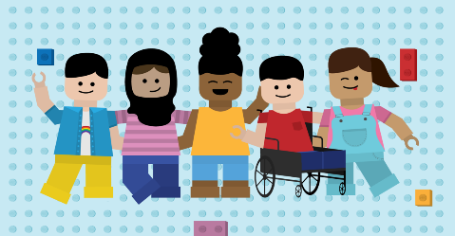  Join us! October 22nd 2:30pm in our auditorium Parent Event: What is Bullying?  - How to recognize bullying.  - What to do if your child is being bullied.  - Who can help you here at school?

PAINT

ROCKIN’ Relationships

RESPECT, OWNERSHIP, CURIOSITY, KINDNESS, INTEGRITY, & NEVER GIVING UP = Our ROCKIN’ Values
How can you use your ROCKIN’ values to be a good friend?  By being KIND and helping my friends when they don’t know something. ~Adriel, class 201  By showing them RESPECT and love. ~Amber class 503  By just being yourself, you don’t have to act fake. Choose KINDNESS! ~Ana, class 403  By showing KINDNESS and sitting next to a new student so they feel welcome. ~Rhachel ~class 301 | By listening when they talk and being quiet because that’s how you show them RESPECT. ~Dyaire, class 301  By showing KINDNESS even when people are disabled or different from you. ~Bilal, class 303  By using KINDNESS and sharing my lunch when someone forgets his own. ~Kate, class 202  By showing CURIOSITY by asking friends about themselves and what I don’t know and telling them about me. ~Cyan, class 202  By telling your friend to Never Give Up when they are having a hard time! ~Julio, class 203
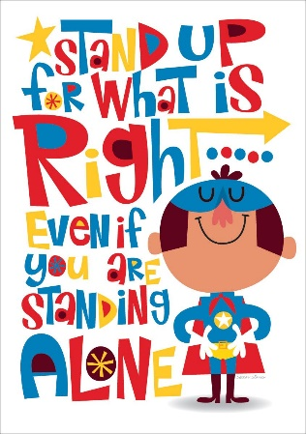
The A-Team Battles Bullying

The P.S. 396 community takes great pride in making our school a safe and caring place for all students. Our School Counselors, Ana Martinez-Hollinger, Angela Cherry and Adriano Casimiro, aka “The A-Team,” offer many conflict resolution strategies for our students including identifying different peer dynamics within small groups, honest conversations, play therapy and role-playing. We focus on students’ developing friendship skills and children’s developmental needs.

We are as flexible as possible to ensure that we are meeting all of our students’ social-emotional needs. For this reason we prohibit harassment against students in school; including real or perceived harassment based on race, color, weight, national origin, ethnic group, religion, religious practice, disability, sexual orientation, gender (including gender identity and expression) and we prohibit discrimination based on these same characteristics. We encourage and reinforce the genuine approach of treating each other with respect, and we refuse to tolerate bullying in any form. We encourage our students. If your child is feeling bullied, reach out to a member of the A-Team for immediate support. However, we do ask that for the safety of our students and community, do not directly approach another child or parent here at school. Remember we are here to help! ~The A-Team

