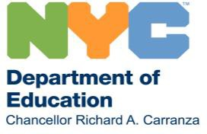
June 12, 2020
Dear Families,
I hope you are staying safe and healthy. We are heading towards the end of the school year, soon to close the chapter on an experience none of us could have imagined.
But while we are thinking about concluding one chapter, we are focused on the beginning of another: what the future of our schools will look like, and how we will come back in September for the 2020-21 school year. I am writing today with an important update and an opportunity to lend your voice to the planning for this fall.
You, your children, and all the staff at DOE have done an extraordinary job adjusting to a total transformation of education in the nation’s largest public school system. We must continue to center health and safety and be prepared to follow guidance issued by health experts and other important authorities as autumn approaches. Since we don’t know what the state of the coronavirus will be at that time, we must be ready for a number of options for teaching and learning. In addition to the risks posed by COVID-19 directly, we are acutely aware of the emergence of Multisystem Inflammatory Syndrome in Children (MIS-C), a condition related to COVID-19 that has affected children in New York City as well as across the country and the world.

What Might Fall 2020 Look Like?
We have not yet made any firm decisions for what this fall will look like as we start the 2020-2021 school year. However, we believe that all options will need to take into account social distancing. We know that for many students, nothing can quite match full-time teaching and learning in a school building. Given the ongoing health risks related to COVID-19, we also need to prepare for a variety of educational models and approaches, including what I call blended learning. Blended learning means combining in-person and remote instruction to create a powerful educational experience where each mode of learning supports the other. Throughout it all, the goal remains to provide as much in-person learning as possible, and give every child the academic support they need while keeping them safe.

Lend Your Voice Through the Return to School 2020 Survey
There are many ways blended learning can operate, and we know every student and family has experienced remote learning differently. We want to hear from you about your preferences and concerns as we head into the 2020- 2021 school year. We have created a short survey for both families and students—please take a moment to fill it out and share your thoughts by Monday, June 22. The survey is anonymous and should take about 7 minutes to complete. It’s available in 9 languages at schools.nyc.gov/returntoschool2020, and those without the ability to complete it online can do so by calling 311. Thank you in advance for taking the time to again give us your feedback: it will help us to better serve you.
Working together, we will build a strong, just, safe, and successful future for our schools and our City. Sincerely,
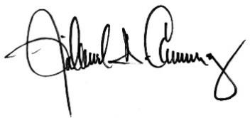
Richard A. Carranza Chancellor
New York City Department of Education

