Mrs. Holly Price
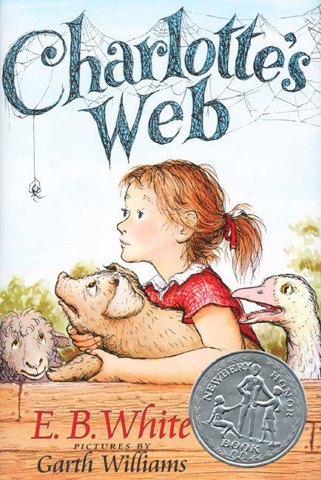
A Book Review for
Charlotte’s Web
Author: E.B White

This is one of my favorite books. My favorite part of the book is how the author illustrates the importance of kindness and friendship between characters. I also love the at the very end when Wilbur sends off Charlotte’s babies into the world. This shows how much he valued Charlotte’s friendship that he would watch over her babies and send them off into the world with words of kindness. I would absolutely recommend this to a friend!
Rating: 5 stars!

