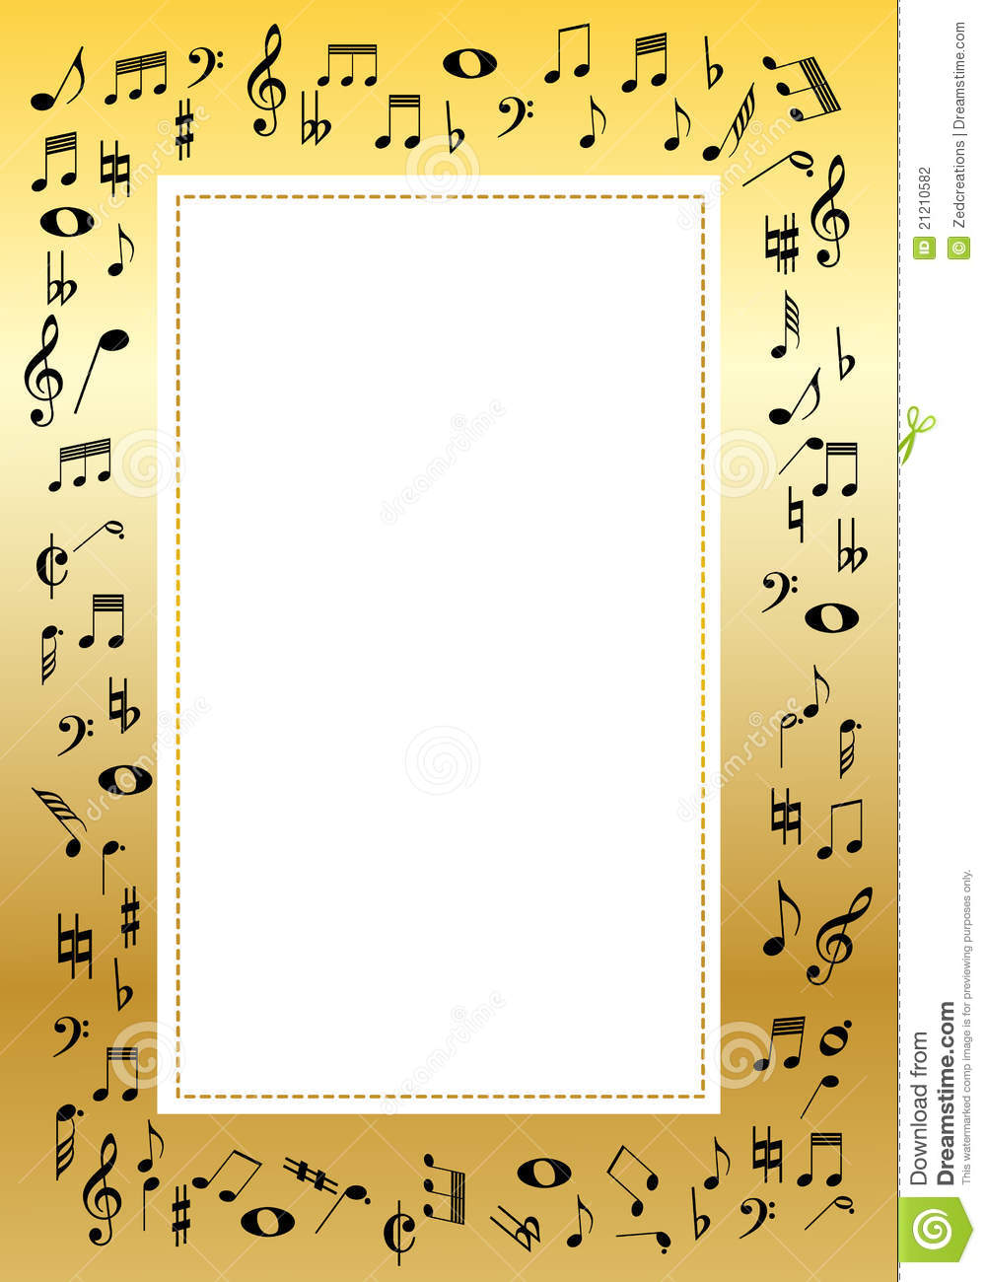

**Third Grade**

Our third graders’ video concert is currently being filmed! Please make sure that your current email address is available to your child’s classroom teacher so that you can receive a link to the video once it is produced and shared.l. Each child is reminded that they can positively affect their report card grades by practicing at home and returning a signed practice log each month. The students are also excited to create “Class Craft” characters on our interactive positive reinforcement website. Remember, all students who take an instrument are required to return it in June and must bring it to class each week. If the recorder is damaged or lost, a parent must contact me.

**Fourth and Fifth Grade**

Our fourth and fifth graders are engaging in song writing and are excited about upcoming Little Kids Rock contests and events to showcase their compositions. Each student is responsible for submitting one finished piece by the end of the year for evaluation, but may finish writing dozens of songs by the end of the year. Students may present their songs by performing them, or submitting a song chart or song book as detailed in class. Students are encouraged to keep a song journal so that none of their amazing ideas are misplaced or forgotten!



**First and Second Grade**

Our 1st and 2nd grade students are learning about Camille Saint-Saens’ “Carnival of the Animals” and exploring the poems by Ogden Nash that were inspired by this whimsical piece. Each musical piece teaches us a lesson, for example: “Fossils” teaches us the ABACA or Rondo form. Links to charts and games to support these lessons are available on my website: [www.shackmanmusic.weebly.com](http://www.shackmanmusic.weebly.com)

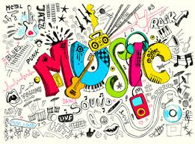

**Kindergarten**

Our Kindergarteners are learning about Camille Saint-Saens’ “Carnival of the Animals” and how the composer shows us the animal’s gestures and movements through music. We are practicing mime and movement to create our own interpretations of this musical menagerie. Links to charts and games to support these lessons are available on my website: [www.shackmanmusic.weebly.com](http://www.shackmanmusic.weebly.com)



**Music**

**MAY 2019**

**With Mr. Shackman**