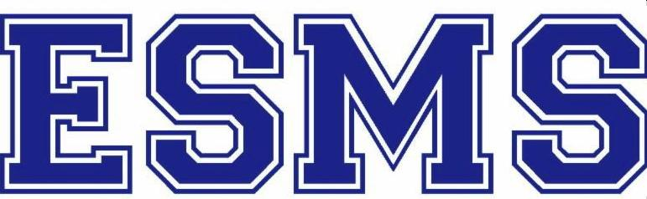

Winter 2020-21

Hello, D2 Fifth Grade Families!

We hope adults and children interested in East Side Middle School will take some time to watch a few videos made by our students and staff to give you a feel for our school.

Admin on Zoom: Principal David Getz and AP Amanda Hyman discuss curriculum, priorities and school-day schedule
ESMS Open House overview video (2019)
ESMS student-made video Students talk about classes, clubs & activities (Orientation spring 2020), with the following timestamps:

Humanities - 0:04
Math - 2:26
Science - 3:22
Dance - 4:15
Spanish - 5:49
Intensives - 6:53
Electives - 7:52
Extra Help - 8:47
Out Lunch - 9:54
Reading Buddies - 10:22
Big Buddies - 11:10
Afterschool - 12:02
Sports - 12:46
Student Council - 13:58
Helping Homeless Women Committee - 14:35
Skype Kenya - 15:40
Rocket Club - 16:54
Poetry Club 17:53
Writers Workshop - 18:32
Fall Fest - 18:57
The Short Story Club - 19:18

Mission & Overview
East Side Middle School's goal is to help our students experience life in their ideal educational community.

The East Side Middle School staff is dedicated to creating a community of rigorous learning and inquiry through an intensive study of mathematics (Algebra I Regents for all in 8th Grade); earth, life and physical science; Spanish and humanities (including history, social studies, all forms of literature, and both fiction and non-fiction writing). We are also driven to create a school environment in which our students can pursue their talents, dreams and ambitions, their "element." With that in mind, we offer rich dance and visual arts programming. Finally, we reinforce staying healthy and physically active, with a thriving physical education/fitness program and a wide variety of team sports and movement opportunities traditionally available after school.

Staff at ESMS are dedicated to the academic success of all our students. Special education and general ed teachers have collaborated to create an enhanced, unified academic program for all our learners. All students may attend extra help sessions with their teachers on specific days before or during the school day.

As a school, we prioritize the mental and emotional well-being of our students, offering courses in emotional literacy, resilience, sex ed, anti-bullying and anti-bias. Guest experts from outside organizations have worked with our students on healthy relationships, mental health awareness and more.

Finally, a great emphasis at ESMS is placed on creating an environment that encourages students to develop their leadership skills and their ability to organize each other to accomplish their goals of improving their school, community, city and beyond.

At Open Houses and Orientation, we generally share a few articles and short videos to explain our philosophy:
How to Help Every Child Fulfill Their Potential (video: Carol Dweck on Growth Mindset)
Do Schools Kill Creativity? (video: Sir Ken Robinson)
Why Parents Need to Let Their Children Fail (Article: What happens to students who aren't allowed to suffer through setbacks.)
Don't Help Your Kids with Their Homework (Article: Insights from a ground-breaking study of how parents impact children’s academic achievement)

In-School Clubs
We have a big Student Council, with representatives from every homeroom who join committees involved in mental health advocacy, anti-hunger and recycling campaigns, and meeting the needs of our local community. Two other large clubs are the Helping Homeless Women Committee and the GSA/Gender Sexuality Alliance club. Students also write, edit and distribute The Tiger Times, our monthly school newspaper.

Afterschool
Afterschool is free for all students and is run by Manhattan Youth. Our various compete JV and V sports teams compete in the MSAL/Middle School Athletic League (several of them recent champs!). We also have prize-winning Debate & Model UN teams; creative & athletic clubs; a school musical; and a study hall.

East Side Middle School
331 East 91 Street (02M114) New York, NY 10128
Between First & Second Avenues

David Getz, Principal
Amanda Hyman, Assistant Principal
Lori McDermott, Admissions esms.lori@gmail.com

Getting here is easy…
Subway: Q to 86th or 96th; 4, 5 to 86th; 6 to 96th
Bus: M101, 102, 15, 15-SBS, 31, 86, 96

See more about us on www.esms.org

