PS 396
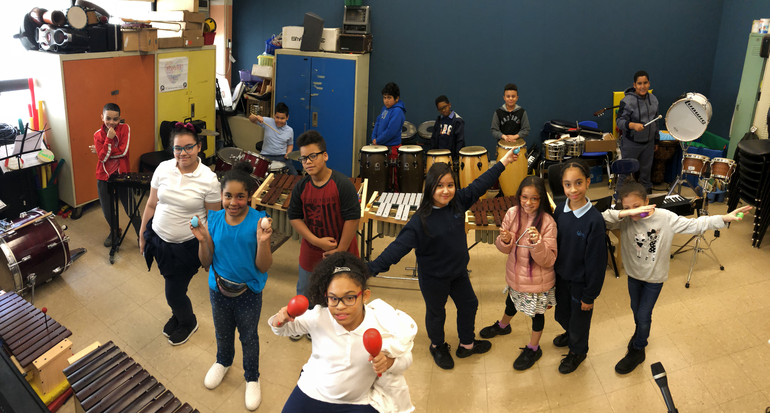
BURNSIDE BEATS
Issue #6, June 2019
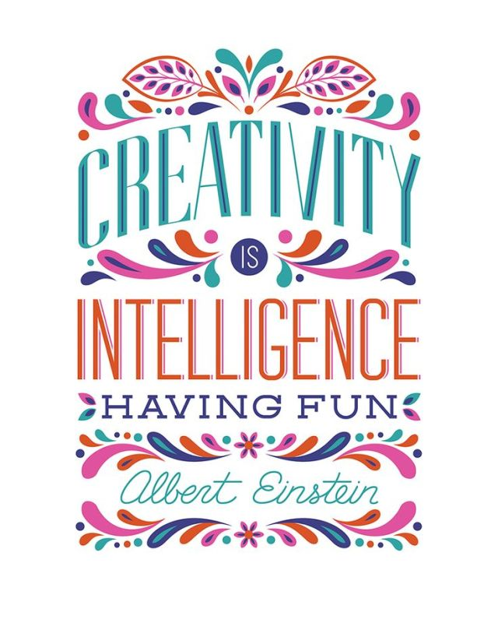
4th Grade Choir

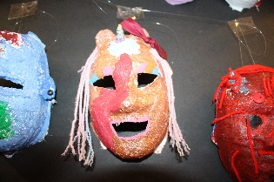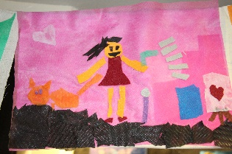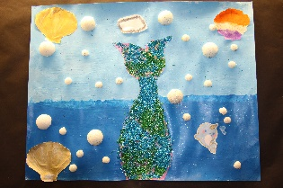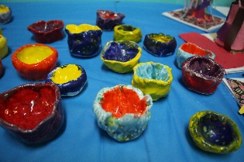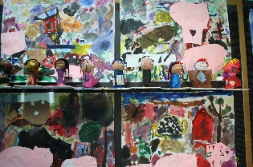
Enriching the Curriculum
Why the arts are so important at PS 396
A Message from our Principal, Nicole A. Tiné…

As the Principal, I am often asked why I put such an emphasis on the arts at PS 396? Wouldn’t our school community be better served by more tutoring programs to help struggling readers or more funding for science materials, or math books instead of readers’ theater, choir and field trips to the MET? Simply put, I have a strong belief that all students have a right to rich engaging experiences. I believe that it is our obligation as educators to provide our students with opportunities that bring them joy, foster creativity and connect them to the wider world. The arts do this for our children and more.

In music class, I have seen our students learn new vocabulary, collaborate to write original music, and make connections to what they are learning in social studies and science. In art class, I have seen our students create a museum exhibit based on current events while learning about color, layout, perspective and presentation. In readers’ theater, our children learn how to be public speakers, how to use their body language and voice to convey their emotions and ideas. I could go on and on about how student performances allow build a strong sense of community while students work together to accomplish their goal and they give all students, strong and struggling alike moments to shine.

This is not to say that academics are not important obviously they are, but we need to think beyond testing to continue to motivate our students and the arts have been shown to improve attendance, raise test scores and promote reading skills. I know I credit my own music, theater, art and dance teachers for inspiring me, challenging me and helping me to find my way to becoming your Principal here at 396. Therefore, I will continue to keep the arts at the center of our curriculum and hope to see you at our next performance!

For even more information about the importance of the arts in education check out this NY Times article: https://www.nytimes.com/2019/03/04/well/family/using-arts-education-to-help-other-lessons-stick.html

Check us out on the web:  www.PS396.org |  | VISUAL ARTS  Our art teacher, Ms. Kourkoulis, is not only our resident artist and art teacher she is also a graduate instructor from the Art & Art Education Program at Teachers College, Columbia University. Over the past two years, she has brought her students up to P.S. 396 to collaborate with individual classes and their teachers on interdisciplinary art projects of their choice. The approach to projects is both organic and multi-dimensional to encourage personalized artistic responses to community challenges, global events, environmental and social issues. Some of the projects they have worked on include “Art as Advocacy: Protest for Animal Rights”, “Recycling: Designing and Prototyping Solutions”, “The P.S. 396 Cultural Times Museum”, and “Fantastic Ceramic Creatures”. Ms. Kourkoulis looks forward to continuing this meaningful art-making partnership with Teachers College for years to come.  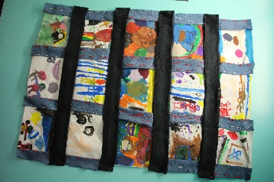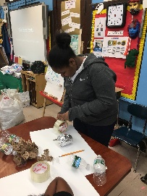  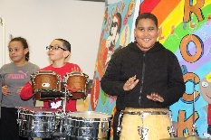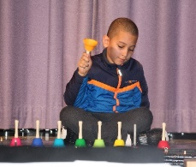  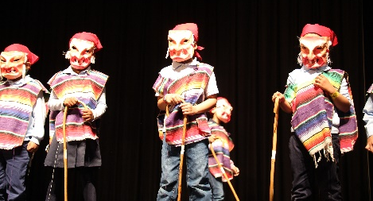  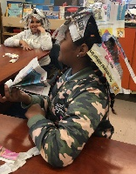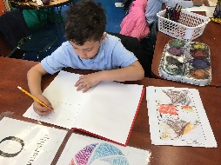  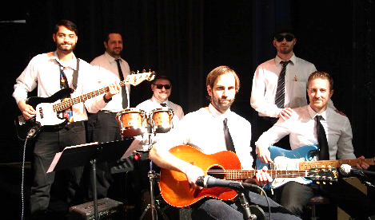

PAINT

ROCKIN’ THE ARTS

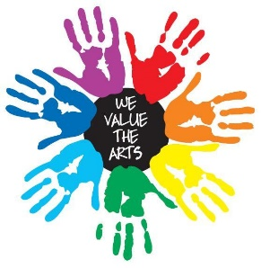
RESPECT, OWNERSHIP, CURIOSITY, KINDNESS, INTEGRITY, & NEVER GIVING UP = Our ROCKIN’ Values
R- Respect your classmates by encouraging them to show off their best artistic abilities, in the art room and on stage during performances.

O- Take Ownership by creating art pieces that can change the world. Recognize ways you can do better as a citizen and reflect on that in your art and music.

C- Show Curiosity as you learn about art and music from around the world! Asking questions like “Where is this artist from?”; “What parts of their culture is incorporated in this song?”

K- Display Kindness to others while you collaborate with classmates in the music or art room, or as you work on performance together in readers’ theater.

I- Show Integrity as you memorize your lines for an upcoming performance, practice songs for a concert, or plan your art pieces over your weekends or vacations!

N- Never Give Up as you persevere through a performance on stage!
IT’S YOUR TIME TO SHINE : )

Choir with Mr. Dietmann & Mr. Pellerin
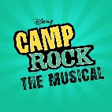
Music has always had a strong presence here at P.S. 396, but now students have the opportunity to further their vocal skills and join Select Choir. For the past two years, any 3rd, 4th, or 5th grader can sign up to be part of this select performing group. Each group rehearses two days a week during their lunchtime. WOW! The OWNERSHIP and commitment each student demonstrates is amazing, giving up a few days of recess and time with their friends to participate. Last year’s performances were a success and this year we have had even more fun. 3rd grade Choir performed with Ms. Tiné at an assembly recently and we had a blast! Our upcoming shows are: June 14th at 8:50am-3rd and 4th grade choir perform- June 18th and 19th at 8:50am 5th grade choir performs! We hope to see you there!

Our Musical Theater Club
P.S. 396’s “Broadway on Burnside” Musical Theater Club (MTC) has been singing, dancing and performing various classic musicals since 2012. Through the years, students from grades 2-5 have performed the following productions: Annie, Wizard of Oz, Beauty and the Beast, Willy Wonka and the Chocolate Factory, The Lion King, Peter Pan, Aladdin and this May, Camp Rock will make its way on stage; under the direction of Dr. Nancy Camacho, Jonathan Pellerin and Katie Dizzine.

MTC’s application process begins in September, with auditions in October and rehearsals right up until their performance in May. Student and parent contracts are submitted as a form of commitment and dedication towards a successful musical production; year after year. Our students display ownership as they attend weekly and weekend rehearsals in preparation for their “show stopping” productions!

