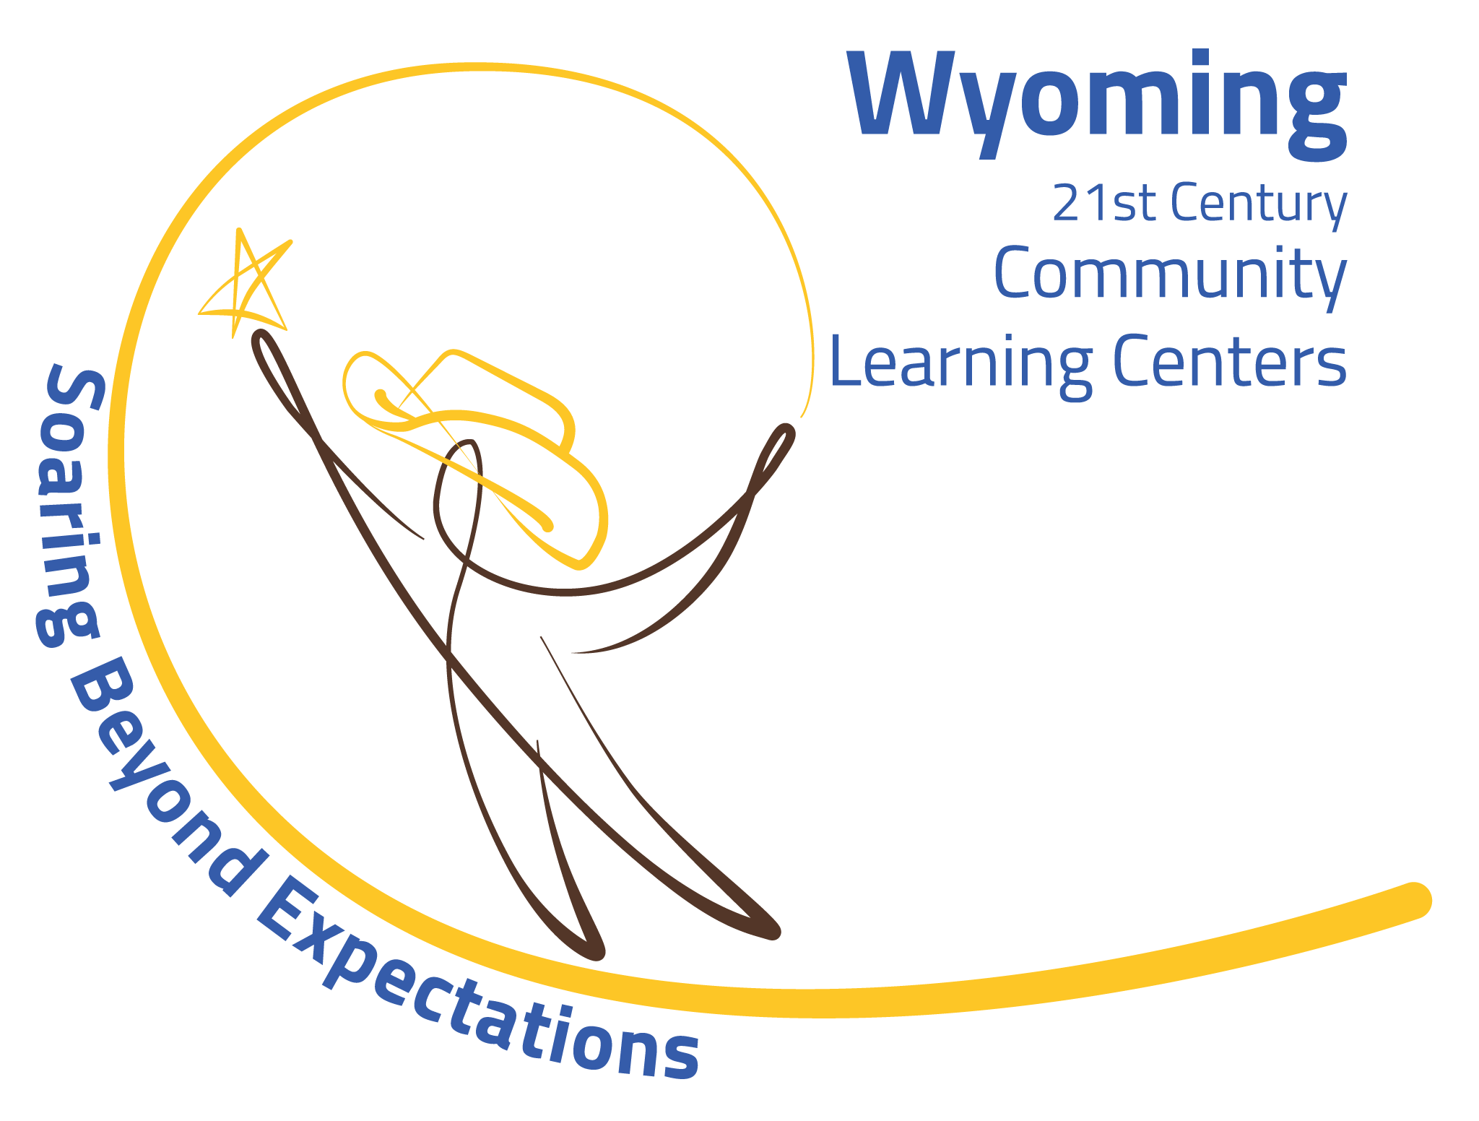
Lesson Plans for Year 3 Cohort 12R2

2020-2021 First Semester

Programs:
- Community Connections including Virtual Job Shadow, NASA Civics project and Community Engagement, Social and Emotional components including our district’s activities and Wings for Kids, and Family Involvement.

This Year our theme is: Fly Me to the Moon. We will research and build around the theme of space transportation and plant/food development. NASA Civics and Community Engagement.

Week 1 – Get all handouts and supplies ready for the week.
9/28/20 to 10/2/20

Tuesday 10-06-20: Send registered students virtual invite for 3:00.
Welcome and Introductions. Go over rules for 21st Century Community Learning Center programs. Take pre-test and do Ice Breakers. Do inspirational You Tube video.

Week 2 –
Wednesday 10-14-20: Send meeting invite at 3:00 to all registered attendees.
3:30 – 4:30 – Introduction to Space with Nasa Space Shuttle Tour.
Discuss Civic Project (voting in the USA) and Community Engagement (putting together a virtual celebration).

Week 3-
Wednesday 10-21-20: Send meeting invite at 3:00 to all registered attendees.
3:30 – 4:30 – Start work on Civic Project and Community Engagement.
NASA film on space food preparation. Discuss how we could build a home hydroponic system with used milk cartons, soil and seeds. Discuss ideas on how we can become involved in the political voting process. Discuss how we can start marketing our virtual celebration, including sponsors, public service announcement, funding sources, venues and audience.
Next week discussion on on-going Family Involvement.
- How can we teach our families about the school platforms including Canvas, Zoom, etc.?
- How can we offer virtual dinner nights and/or recipe exchanges and food preparation?
- How can we offer virtual Math Game Nights?

Week 4-
Wednesday 10-28-20: Send meeting invite at 3:00 to all registered attendees.
3:30 – 4:30 – Further discussion on our Civic Project as the Election Day is quickly approaching.
NASA Project – How do we grow food in Space? How will we get it there? NASA film on projecting items safely to the Space Station.

Week 5 -
Wednesday 11-04-20:
3:30 – 4:30 – Open discussion on election results. Start Virtual Job Shadow curriculum if available. Look up potential careers. Start SEL Yoga and discuss other SEL options for the remainder of the semester.

Week 6 –
Wednesday 11-11-20:
3:30 – 4:30 – Continue with VJS – Practice SEL Yoga. Work on Community Engagement Virtual Celebration. Send out email calendar invites to all community members and family.

Week 7 –
Wednesday 12-02-20:
3:30 – 4:30 – Work on NASA Fly me to the Moon project. Watch U-Tube videos not covered yet. Work on VJS career exploration. Discuss Community Celebration and what needs do still be planned and followed through.

Week 8 –
Wednesday 12/09/20:
3:30 – 4:30 – Wrap up our NASA Fly Me to the Moon – Reflection.
Wrap up our VJS for semester – Reflection.
Complete last details for next week’s Community and Family Celebration!

Week 9 –
Wednesday 12/16/20:
Celebration and Happy Holidays!

