Pelham Union Free School District
FOR IMMEDIATE RELEASE: Contact: Alex Wolff
Friday, May 5, 2017 awolff@pelhamschools.org
914-738-3434 ext. 1131

Two PMHS Juniors Qualify for National History Day Competition
Exhibit Won First Place at State Championship

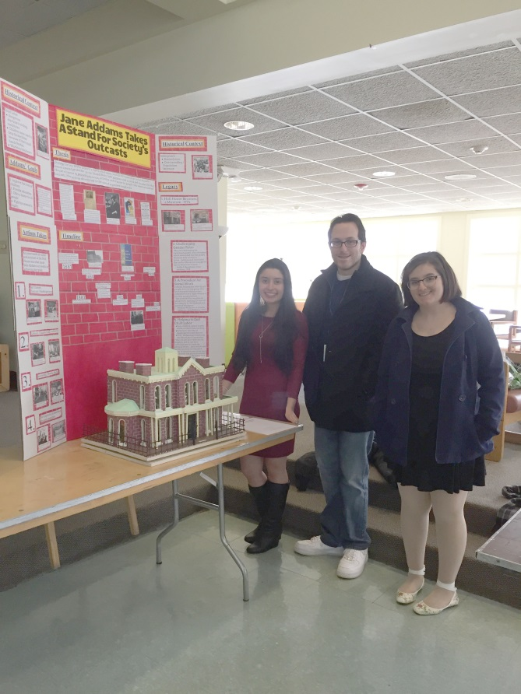
Karla Pennetta, teacher Marc Sirico and Natalie Todaro
Two PMHS juniors will travel to the University of Maryland the week of June 11 to represent New York State and present their group exhibit at the National History Day Contest.
Juniors Karla Pennetta and Natalie Todaro earned first place at the state competition for their exhibit titled “Jane Addams: Taking a Stand for Society’s Outcasts,” earning them the trip to Maryland and the chance to compete for several awards and prizes.
“It’s very nerve-racking,” admitted Pennetta. “There’s going to be so many people competing here against us, but it’s a very good experience, and we got a lot of research experience that is college-level .”
This year’s National History Day theme was “Taking a Stand in History and” and students selected a specific historical event or person who either took a stand, or decided not to as the basis of their project. Pennetta and Todaro said that they chose to research the life of Jane Addams, a pioneer in social work, who founded the nation’s first settlement house, known as Hull House, and was a co-founder of the ACLU, because of her broad reach across multiple disciplines that are important to them.
“I wanted to do a lot of different things involving immigration, child labor, and women’s rights and Jane Addams was an umbrella for all those things that I wanted to do,” Pennetta said.
Todaro explained their research used a variety of sources to help gain a complete understanding of the effects of Addams life and work.
“A lot of primary sources were from people that lived at Hull House or visited it or who knew Jane Addams,” Todaro said. “The secondary sources were outsiders’ views, like people from today who looked back on her.”
In addition to Pennetta and Todaro placing first, freshman Helen Meyerson, who also competed at the state competition, earned The Town of Middlefield Historical Association Award for an outstanding entry that focusses on a rural history topic for her project titled “Beatrix Potter; Taking a Stand For the Appreciation and Preservation of Wildlife.” In the junior competition, eighth grader Emily Kalyvas earned third place for her Historical Paper titled “Katherine Johnson: The Woman Computer Who Significantly Altered the Space Race.”
Each year, all Pelham Middle School 8th graders and PMHS 11th graders compete in the NHD competition in which the students, working individually or in groups, conduct primary and secondary research to create an exhibit, historical paper, live performance, documentary or website around a common theme. This year, 10 middle school students and five PMHS students made it to the state level, with Pennetta and Todaro now moving on to nationals. Through their work, the students analyze and interpret their sources and draw conclusions about the significance of their chosen topic.

###

