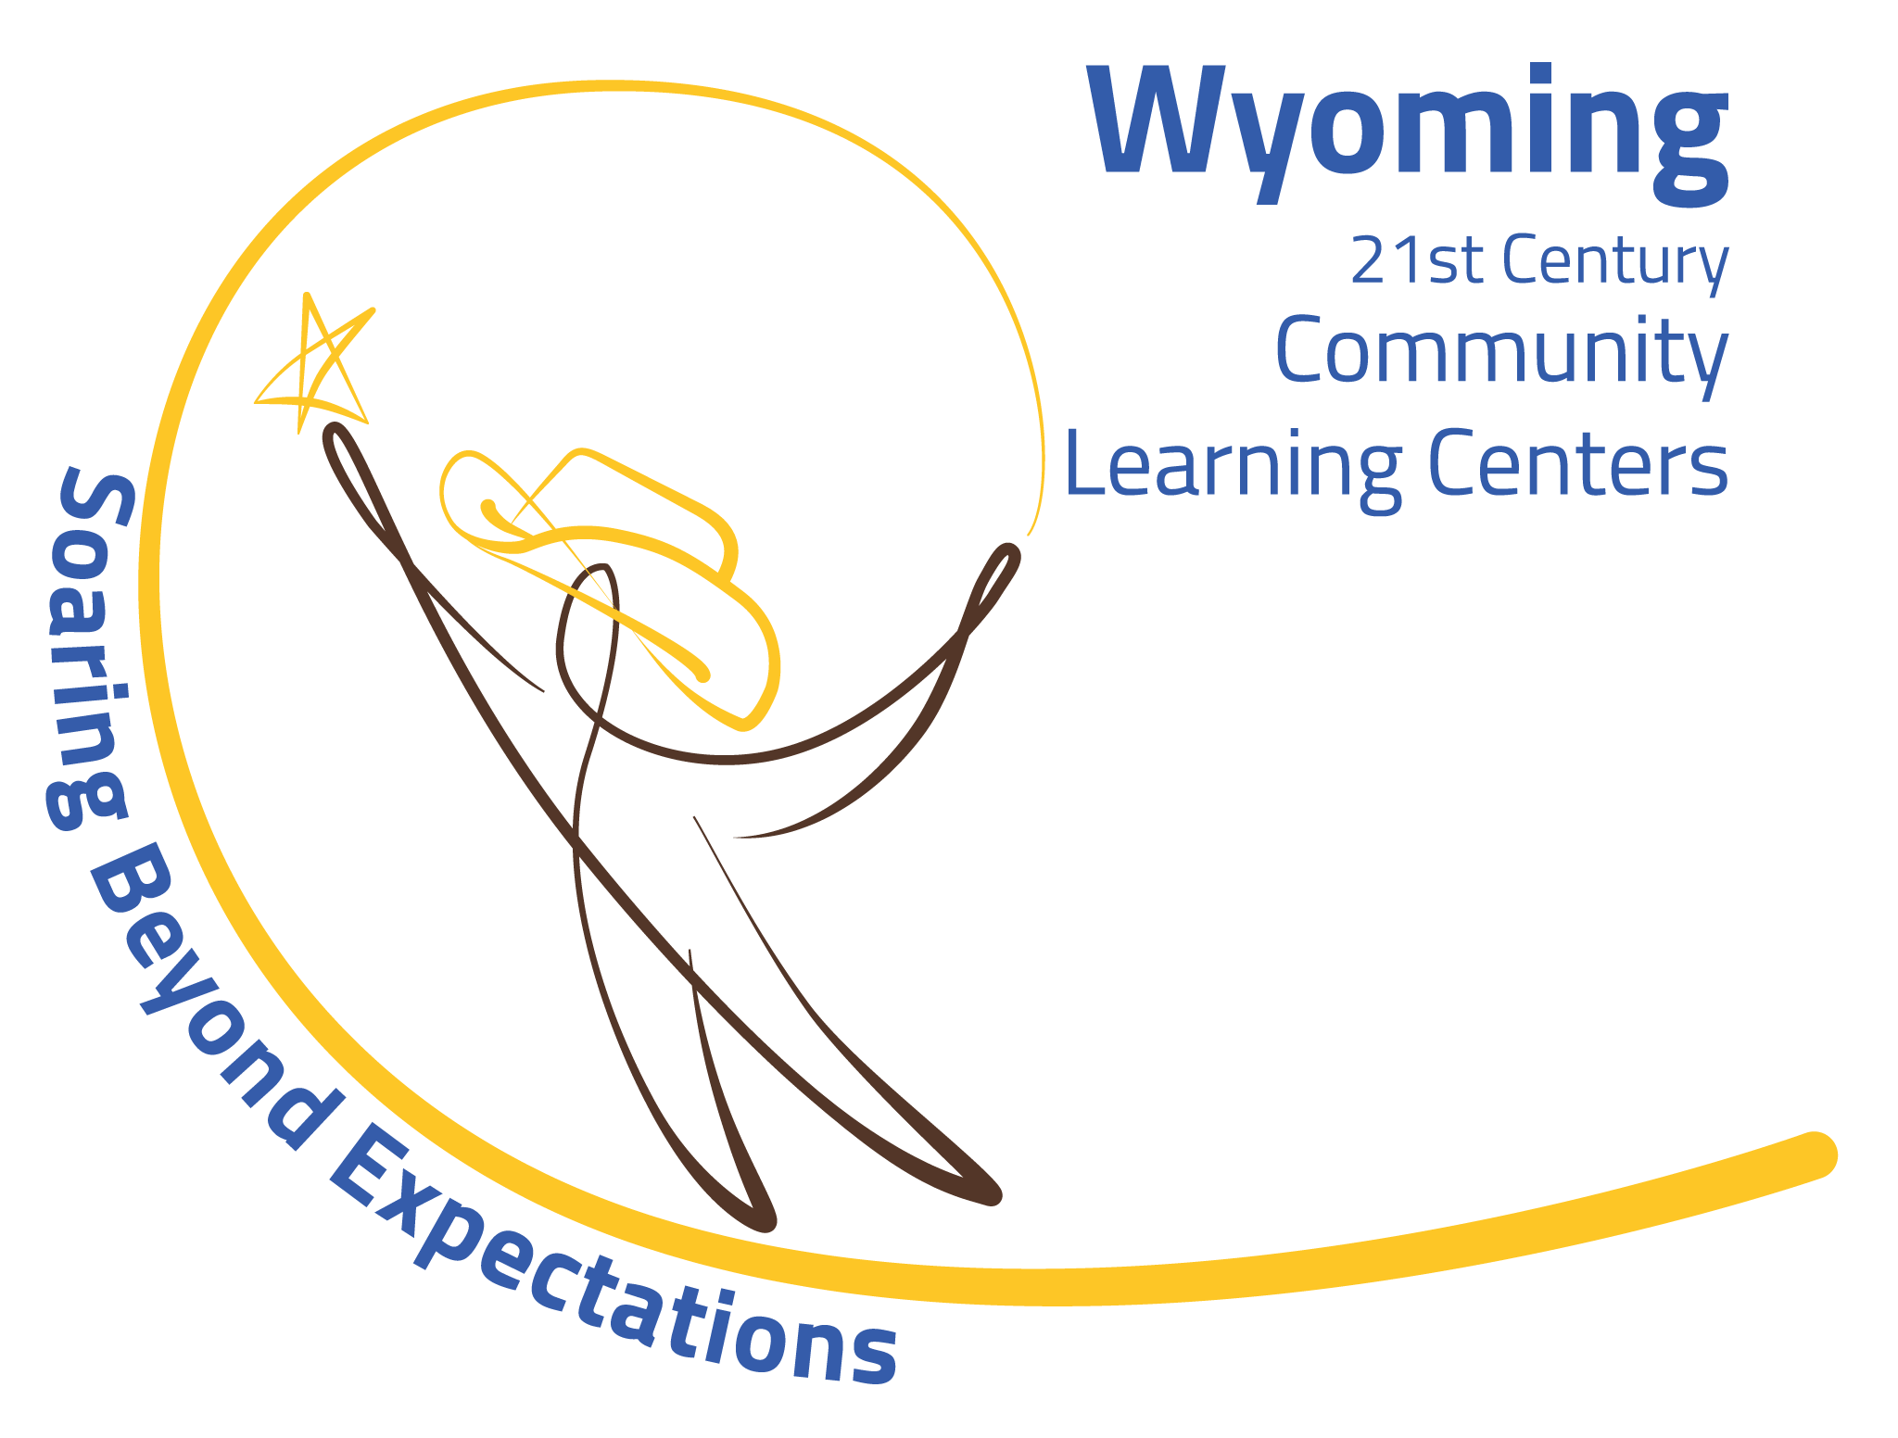
Lesson Plans for Year 2 Cohort 12R2

2019-2020 First Semester

Programs:
- Yearbook – Newsletter Julie Petersen, Lisa Plant and Andrea Carroll
- Robotics/Coding Club - Sewing Club - Homework Club – Tuesday/Thursday Jere Bottgenbach, Katie Nash, and Jennifer Copeland and Julie Petersen
- Library Makerspace – Monday and Wednesday
- Breakfast Club – Wednesday
- Community Connections – Monday/Tuesday/Wednesday/Thursday Traveling Reading Club, the Humane Society, Young at Heart Day Care, Recycling, the Medal of Honor Character Building, and Project-Based Learning including time to travel through time with trains and structure. Lisa Plant and Julie Petersen. Until we get a bus driver, Julie will help Lisa Monday/Wednesday with the Newsletter Club and Jennifer Copeland Tuesday/Thursday with the Homework Club.

This Year we will teach: Time to Travel Through Time. We will research and build around the theme of trains from their inception to the modern superliners. Structures will also be incorporated in our theme including hammocks and tents.

Week 1 – Get all handouts and supplies ready for the week.
9/16/19 to 9/19/19

Monday 9-16-19: Suicide Prevention all staff from 2:45 to 4:00. Lisa Plant will join Eastside on September 10 so she can teach all students today.
2:45 –4:30 Welcome and Introductions. Take attendance and hand out snack. Go over rules for 21st Century Community Learning Center programs. Go over rules for the Foods room. Take pre-test and do Ice Breakers. Do inspirational You Tube video.
4:30 – 4:45 Clean classroom and come together for bus.

Tuesday 9-17-19:
2:45 – Take attendance and hand out snack.
3:00 – 4:45 Robotics/Coding Club Jere Bottgenbach.
Sewing Club will start Thursday September 26.
3:00 – 4:45 Homework Club Jennifer Copeland and Julie Petersen.
4:30 – 4:45 Clean classroom and come together for bus.

Wednesday 9-18-19:
2:45 – 3:00 Take attendance and hand out snack.
3:00 – 4:45 Breakfast Club Katie Nash.
3:00 – 4:45 Library Makerspace Brenna Copeland.
2:45 – 4:45 Community Connections PBL topic for school year and start Newsletter Team Lisa Plant and Julie Petersen.
4:30 – 4:45 Clean room and come together for bus.

Thursday 9-19-19: Snack
2:45 – 3:00 Take roll – hand out snack.
3:00 – 4:45 Robotics/Coding Club Jere Bottgenbach.
3:00 – 4:45 Homework Club Jennifer Copeland and Julie Petersen.
4:30 - 4:45 Clean classroom and come together for bus.

Week 2- Get all handouts and supplies ready for the week.
9/23/19 – 9/26/19

Monday 9-23-19:
2:45 – 3:00 Take roll and go over weekly announcements and activities. Hand out snack.
3:00 – 4:45 Library Makerspace Brenna Franklin.
3:00 – 4:45 Newsletter Lisa Plant and Julie Petersen.
4:30 – 4:45 Clean room and come together for bus.

Tuesday 9-24-19:
2:45 – 3:00 Take roll and hand out snack.
3:00 – 4:45 Robotics/Coding Club Jere Bottgenbach.
3:00 – 4:45 Homework Club Jennifer Copeland and Julie Petersen.
4:30 – 4:45 Clean room and come together for bus.

Wednesday 9-25-19:
2:45 - 3:00 Take roll and give out snacks.
3:00 – 4:45 Breakfast Club Katie Nash.
3:00 – 4:45 Newsletter Lisa Plant and Julie Petersen.
3:00 – 4:45 Library Makerspace Brenna.
4:30 – 4:45 Clean room and come together for bus.

Thursday 9-26-19:
2:45 – 3:00 Take roll and give out snack.
3:00 – 4:45 Sewing Club Katie Nash.
3:00 – 4:45 Robotics/Coding Club Jere Bottgenbach.
3:00 – 4:45 Homework Club Jennifer Copeland and Julie Petersen.
4:30 – 4:45 Clean room and come together for bus.

Lisa will be in Cheyenne 9/30/19 – 10/3/19

Week 3- Get all handouts and supplies ready for the week. Rosters and snacks to Julie Petersen.
9/30/19 – 10/3/19

Monday 9-30-19:
2:45 – 3:00 Go over announcements for week. Take attendance and hand out snack.
3:00 – 4:45 Library Makerspace Brenna Franklin.
3:00 – 4:45 Newsletter Julie Petersen.
4:30 – 4:45 Clean room and come together for bus.

Tuesday 10-1-19:
2:45 – 3:00 Take attendance and hand out snack.
3:00 – 4:45 Robotics/Coding Club Jere Bottgenbach.
3:00 – 4:45 Sewing Club Katie Nash.
3:00 – 4:45 Yearbook/Mentoring Andrea Carroll.
3:00 – 4:45 Homework Club Jennifer Copeland and Julie Petersen.
4:30 – 4:45 Clean room and come together for bus.

Wednesday 10-2-19:
2:45 – 3:00 Take attendance.
3:00 – 4:45 Breakfast Club Katie Nash.
3:00 – 4:45 Library Makerspace Brenna Franklin.
3:00 – 4:45 Newsletter Lisa Plant and Julie Petersen.
4:30 – 4:45 Clean room and come together for bus.

Thursday 10-3-19:
2:45 – 3:00 Take attendance and hand out snack.
3:00 – 4:45 Robotics/Coding Club Jere Bottgenbach.
3:00 – 4:45 Sewing Club Katie Nash.
3:00 – 4:45 Homework Club Jennifer Copeland and Julie Petersen.
4:30 – 4:45 Clean room and come together for bus.

Week 4 -
10/7/19 to 10/10/19.
No afterschool on Monday Staff Meeting.

Monday 10-7-19: Staff Meeting.

Tuesday 10-8-19:
2:45 – 3:00 Take attendance and hand out snack.
3:00 – 4:45 Robotics/Coding Club Jere Bottgenbach.
3:00 – 4:45 Yearbook/Mentoring Andrea Carroll
3:00 – 4:45 Sewing Club Katie Nash.
3:00 – 4:45 Homework Club Jennifer Copeland and Julie Petersen.
4:30 – 4:45 Clean room and come together for bus.

Wednesday 10-9-19:
2:45 - 3:00 Take attendance.
3:00 – 4:45 Breakfast Club Katie Nash.
3:00 – 4:45 Library Makerspace Brenna Franklin.
3:00 – 4:45 Newsletter Lisa Plant and Julie Petersen.
4:30 – 4:45 Clean room and come together for bus.

Week 5 – Get all handouts and supplies ready for the week.
10/14/19 to 10/17/19

Monday 10-14-19:
2:45 – 3:00 – Take attendance and hand out snack. Go over weekly announcements and activities.
3:00 – 4:45 Library Makerspace Brenna Franklin
3:00 – 4:45 Newsletter Lisa Plant and Julie Petersen.
4:30 – 4:45 Clean room and come together for bus.

Tuesday 10-15-19:
2:45 – 3:00 Take attendance and hand out snack.
3:00 – 4:45 Robotics/Coding Club Jere Bottgenbach.
3:00 – 4:45 Yearbook/Mentoring Andrea Carroll.
3:00 – 4:45 Sewing Club Katie Nash.
3:00 – 4:45 Homework Club Jennifer Copeland and Julie Petersen.
4:30 – 4:45 Clean room and come together for bus.

Wednesday 10-16-19:
2:45 – 3:00 Take roll.
3:00 – 4:45 Breakfast Club Katie Nash.
3:00 – 4:45 Library Makerspace Brenna Franklin.
3:00 – 4:45 Newsletter Lisa Plant and Julie Petersen.
4:30 – 4:45 Clean room and come together for bus.

Thursday 10-17-19:
2:45 – 3:00 Take roll and hand out snacks.
3:00 – 4:45 Robotics/Coding Club Jere Bottgenbach.
3:00 – 4:45 Sewing Club Katie Nash.
3:00 – 4:45 Homework Club Jennifer Copeland and Julie Petersen.
4:30 – 4:45 Clean room and come together for the bus.

Week 6 - Get all handouts and supplies and materials for the week.
10/21/19 to 10/24/19. No afterschool on Thursday October 24 Parent/Teacher Conferences.

Monday 10-21-19:
2:45 – 3:00 Take attendance and hand out snack. Go over weekly announcements.
3:00 – 4:45 Library Makerspace Brenna Franklin.
3:00 – 4:45 Newsletter Lisa Plant and Julie Petersen.
4:30 – 4:45 Clean room and come together for bus.

Tuesday 10-22-19:
2:40 – 3:00 Take roll and hand out snacks.
3:00 – 4:45 Robotics/Coding Club Jere Bottgenbach.
3:00 – 4:45 Yearbook/Mentoring Andrea Carroll.
3:00 – 4:45 Sewing Club Katie Nash.
3:00 – 4:45 Homework Club Jennifer Copeland and Julie Petersen.
4:30 – 4:45 Clean room and come together for bus.

Wednesday 10-23-19:
2:45 – 3:00 Take roll and hand out snacks.
3:00 - 4:45 Breakfast Club Katie Nash
3:00 – 4:45 Library Makerspace Brenna Franklin.
3:00 – 4:45 Newsletter Lisa Plant and Julie Petersen.
4:30 – 4:45 Clean room and come together for bus.

Thursday 10-24-19:
No Afterschool Parent/Teacher Conferences.

Week 7 – Get all handouts and supplies ready for the week.
10/28/19 to 10/31/19

Monday 10-28-19:
2:45 – 3:00 Take attendance and hand out snack. Go over weekly announcements. No afterschool Thursday Halloween.
3:00 – 4:45 Library Makerspace Brenna Franklin.
3:00 – 4:45 Newsletter Lisa Plant and Julie Petersen.
4:30 – 4:45 Clean room and come together for bus.

Tuesday 10-29-19:
2:45 – 3:00 Take attendance and hand out snack.
3:00 – 4:45 Robotics/Coding Club Jere Bottgenbach.
3:00 – 4:45 Yearbook/Mentoring Andrea Carroll.
3:00 – 4:45 Sewing Club Katie Nash.
3:00 – 4:45 Homework Club Jennifer Copeland and Julie Petersen.
4:30 – 4:45 Clean room and come together for bus.

Wednesday 10-30-19:
2:45 – 3:00 Take attendance and hand out snack.
3:00 – 4:45 Breakfast Club Katie Nash.
3:00 – 4:45 Newsletter Lisa Plant and Julie Petersen.
3:00 – 4:45 Library Makerspace Brenna Franklin.
4:30 – 4:45 Clean room and come together for bus.

Thursday 10-31-19: No afterschool Halloween.

Week 8 – Get all handouts, supplies and materials for the week.
11/4/19 to 11/7/19

Monday 11-4-19: Staff Meeting Monday.

Staff meeting on Monday no afterschool.

Tuesday 11-5-19:
2:45 – 3:00 Take attendance and hand out snacks.
3:00 – 4:45 Sewing Club Katie Nash
3:00 – 4:45 Robotics/Coding Club Jere Bottgenbach.
3:00 – 4:45 Yearbook/Mentoring Andrea Carroll.
3:00 – 4:45 Homework Help Jennifer Copeland and Julie Petersen.
4:40 – 4:45 Clean room and come together for bus.

Wednesday 11-6-19:
2:45 – 3:00 Take attendance and hand out snacks.
3:00 – 4:45 Breakfast Club Katie Nash.
3:00 – 4:45 Library Makerspace Brenna Franklin.
3:00 – 4:45 Newsletter Lisa Plant and Julie Petersen.

Thursday 11-7-19:
2:45 – 3:00 Take attendance and hand out snacks.
3:00 – 4:45 Sewing Club Katie Nash.
3:00 – 4:45 Robotics/Coding Club Jere Bottgenbach.
3:00 – 4:45 Homework Help Club Jennifer Copeland and Julie Petersen.
4:30 – 4:45 Clean room and come together for bus.

Week 9 – Get all materials and supplies ready for the week.
11/11/19 to 11/14/19

Monday 11-11-19:
2:45 – 3:00 Take attendance and hand out snack.
3:00 – 4:45 Library Makerspace Brenna Franklin.
3:00 – 4:45 Newsletter Lisa Plant and Julie Petersen.
4:30 – 4:45 Clean room and come together for bus.

Tuesday 11-12-19:
2:45 – 3:00 Take attendance and hand out snacks.
3:00 – 4:45 Robotics/Coding Club Jere Bottgenbach.
3:00 – 4:45 Yearbook/Mentoring Andrea Carroll.
3:00 – 4:45 Sewing Club Katie Nash
3:00 – 4:45 Homework Help Club Jennifer Copeland and Julie Petersen.
4:30 – 4:45 Clean room and come together for bus.

Wednesday 11-13-19:
2:45 – 3:00 Take attendance and hand out snacks.
3:00 – 4:45 Newsletter Lisa Plant and Julie Petersen.
3:00 – 4:45 Breakfast Club Katie Nash.
3:00 – 4:45 Library Makerspace Brenna Franklin.
4:30 – 4:45 Clean room and come together for bus.

Thursday 11-14-19:
2:45 – 3:00 Take attendance and hand out snacks.
3:00 – 4:45 Sewing Club Katie Nash
3:00 – 4:45 Robotics/Coding Club Jere Bottgenbach.
3:00 – 4:45 Homework Help Club Jennifer Copeland and Julie Petersen.
4:30 – 4:45 Clean room and come together for bus.

Week 10 – Get all handouts and supplies ready for the week.
11/18/19 to 11/21/19

Monday 11-18-19
2:45 – 3:00 Take attendance and hand out snacks.
3:00 – 4:45 Library Makerspace Brenna Franklin.
3:00 – 4:45 Newsletter Lisa Plant and Julie Petersen.
4:30 – 4:45 Clean room and come together for bus.

Tuesday 11-19-19
2:45 – 3:00 Take attendance and hand out snacks.
3:00 – 4:45 Robotics/Coding Club Jere Bottgenbach.
3:00 – 4:45 Yearbook/Mentoring Andrea Carroll.
3:00 – 4:45 Sewing Club Katie Nash
3:00 – 4:45 Homework Help Club Jennifer Copeland and Julie Petersen.
4:30 – 4:45 Clean room and come together for bus.

Wednesday 11-20-19
2:45 – 3:00 Take attendance and hand out snacks.
3:00 – 4:45 Newsletter Lisa Plant and Julie Petersen.
3:00 – 4:45 Breakfast Club Katie Nash.
3:00 – 4:45 Library Makerspace Brenna Franklin.
4:30 – 4:45 Clean room and come together for bus.

Thursday 11-21-19
2:45 – 3:00 Take attendance and hand out snacks.
3:00 – 4:45 Robotics/Coding Club Jere Bottgenbach.
3:00 – 4:45 Sewing Club Katie Nash
3:00 – 4:45 Homework Help Club Jennifer Copeland and Julie Petersen.
4:30 – 4:45 Clean room and come together for bus.

Week 11 – Get all handouts and supplies ready for the week.
11/25/19 to 11/28/19

Monday 11-25-19: No afterschool on Tuesday everyone goes home for Thanksgiving Holiday.
2:45 – 3:00 Take attendance and hand out snack.
3:30 – 4:45 Stay in building and play games and/or watch a movie Julie Petersen.

Tuesday 11-26-19: No afterschool everyone goes home for Thanksgiving.

Week 12 – Get all handouts and supplies ready for the week.
12/2/19 to 12/5/19

Monday 12-2-19: No afterschool Staff Meeting.

Tuesday 12-3-19:
2:45 – 3:00 Take attendance and hand out snacks.
3:00 – 4:45 Robotics/Coding Club Jere Bottgenbach.
3:00 – 4:45 Yearbook/Mentoring Andrea Carroll.
3:00 – 4:45 Sewing Club Katie Nash
3:00 – 4:45 Homework Help Club Jennifer Copeland and Julie Petersen.
4:30 – 4:45 Clean room and come together for bus.

Wednesday 12-4-19:
2:45 – 3:00 Take attendance and hand out snacks.
3:00 – 4:45 Newsletter Lisa Plant and Julie Petersen.
3:00 – 4:45 Breakfast Club Katie Nash.
3:00 – 4:45 Library Makerspace Brenna Franklin.
4:30 – 4:45 Clean room and come together for bus.

Thursday 12-5-19:
2:45 – 3:00 Take attendance and hand out snacks.
3:00 – 4:45 Robotics/Coding Club Jere Bottgenbach.
3:00 – 4:45 Sewing Club Katie Nash
3:00 – 4:45 Homework Help Club Jennifer Copeland and Julie Petersen.
4:30 – 4:45 Clean room and come together for bus.

Week 13 – Get all handouts and supplies ready for the week.
12/9/19 to 12/12/19

Monday 12-9-19:
2:45 – 3:00 Take attendance and hand out snacks.
3:00 – 4:45 Library Makerspace Brenna Franklin.
3:00 – 4:45 Newsletter Lisa Plant and Julie Petersen.
4:30 – 4:45 Clean room and come together for bus.

Tuesday 12-10-19:
2:45 – 3:00 Take attendance and hand out snacks.
3:00 – 4:45 Robotics/Coding Club Jere Bottgenbach.
3:00 – 4:45 Yearbook/Mentoring Andrea Carroll.
3:00 – 4:45 Sewing Club Katie Nash
3:00 – 4:45 Homework Help Club Jennifer Copeland and Julie Petersen.
4:30 – 4:45 Clean room and come together for bus.

Wednesday 12-11-19:
2:45 – 3:00 Take attendance and hand out snacks.
3:00 – 4:45 Newsletter Lisa Plant and Julie Petersen.
3:00 – 4:45 Breakfast Club Katie Nash.
3:00 – 4:45 Library Makerspace Brenna Franklin.
4:30 – 4:45 Clean room and come together for bus.

Thursday 12-12-19:
2:45 – 3:00 Take attendance and hand out snacks.
3:00 – 4:45 Robotics/Coding Club Jere Bottgenbach.
3:00 – 4:45 Sewing Club Katie Nash
3:00 – 4:45 Homework Help Club Jennifer Copeland and Julie Petersen.
4:30 – 4:45 Clean room and come together for bus.

Week 14 – Get all handouts and supplies ready for the week. No afterschool on Thursday for Christmas Holiday.

Monday 12-16-19:
2:45 – 3:00 Take attendance and hand out snacks.
3:00 – 4:30 Library Makerspace Brenna Franklin.
3:00 – 4:30 Newsletter Lisa Plant and Julie Petersen.
4:30 – 4:45 Clean room and come together for bus.

Tuesday 12-19-19:
2:45 – 3:00 Take attendance and hand out snacks.
3:00 – 4:30 Robotics/Coding Club Jere Bottgenbach.
3:00 – 4:30 Yearbook/Mentoring Andrea Carroll.
3:00 – 4:30 Sewing Club Katie Nash
3:00 – 4:30 Homework Help Club Jennifer Copeland and Julie Petersen.
4:30 – 4:45 Clean room and come together for bus.

Wednesday 12-20-19:
2:40 – 3:15 Take roll and hand out snack.
Free day. Happy Holidays.

