PS 396
BURNSIDE BEATS
Issue #12, February 2020
ROCKIN’ ROLE MODELS
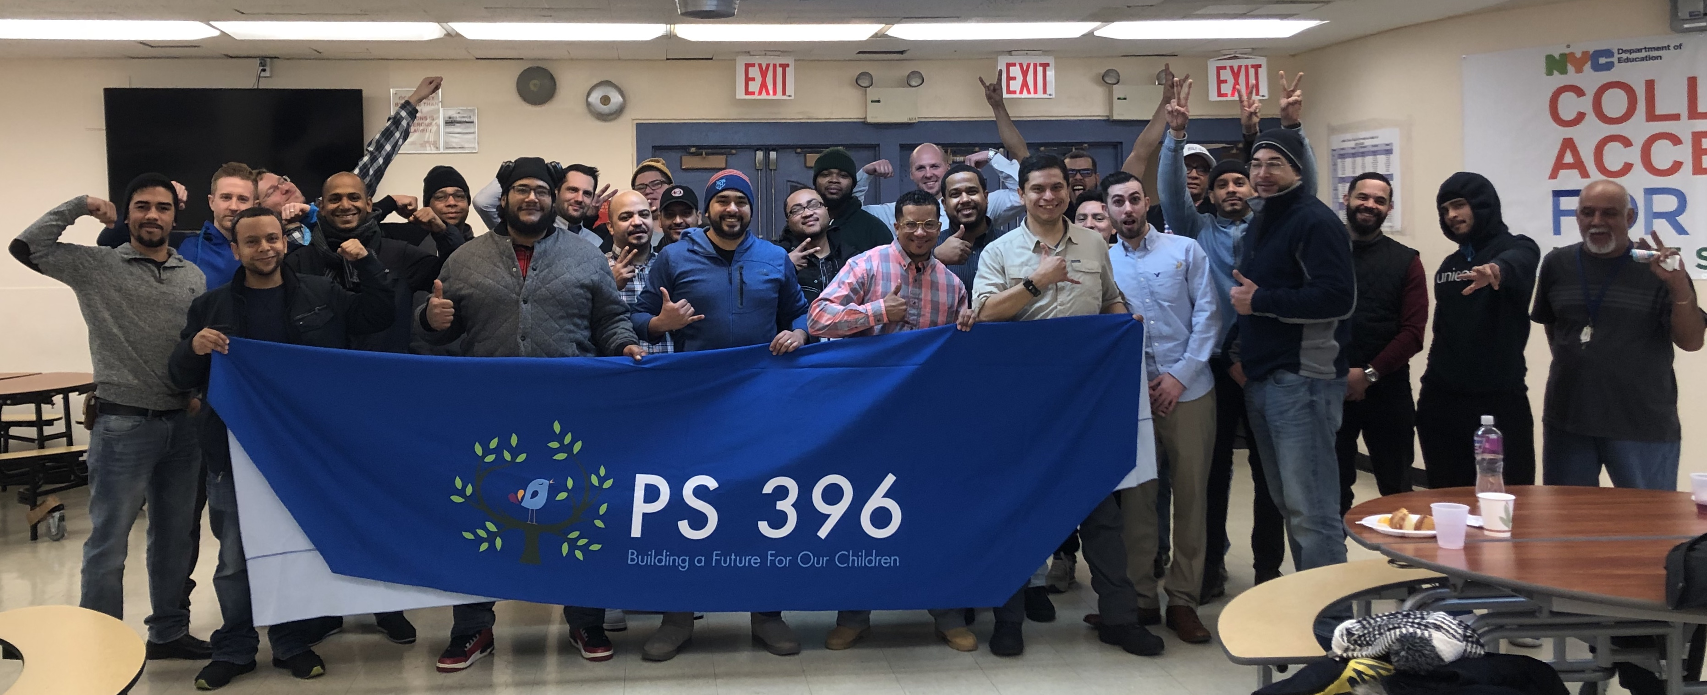
A Message from our Principal, Nicole A. Tiné…
On Thursday, January 23, 2020 we had our first meeting of the “ROCKIN’ Role Models.” Led by one of our School Counselor’s, Adriano Casimiro, the men in our students’ lives came together to discuss how they support their children and how we can help.  After a good breakfast, the guys had an opportunity to to discuss how this year is going for them and their kids. They discussed the challenges they encounter while doing their best to provide for their families and trying to find the time to be involved in school life and just spending time with their kids. As a working Mom myself, I can certainly relate!  Our goal for this group is to see a stronger male presence here at school for our students, giving them a true voice. We want to offer our help in learning more |  | about academic expectations and how they can be a true ROCKIN’ Role Model.  Research shows that involved father figures of all races were associated with significantly better education outcomes for their children. "When fathers are involved, the outcomes are positive across the board in terms of the academic as well as the social and emotional issues," said Tyrone Howard, an education professor at the University of California, Los Angeles, the founder of UCLA's Black Male Institute, and a father of four.  As you can see, our first meeting was a wonderful turnout with a great group of Dads, Step-Dads, Grandpas, older Brothers, Uncles and Friends. We will be |  | hosting five meetings this school year. Those who attend at least four times will receive a family pack of four tickets to attend a Yankee Game with their family this spring!  The next meeting of the ROCKIN’ Role Models will be on Thursday, March 5th at 7:45am. We encourage the guys to bring their children to school and this time we are going to include the kids in the meeting. So it promises to be a fun time. We can’t wait to see you there!
Check us out on the web:  www.PS396.org  K10 Students Reading with their Buddy Bears  Follow us on Twitter:  @PS396BX |  |  |  |  | February 5th  World Read Aloud Day! 8am  February 7th  ROCKIN’ Racial Equity Assembly 8:50am  February 13th  The Little Mermaid  student performance 5pm  February 25th  Game Night for Students with 94%+ Attendance 5pm

ROCKIN at Home!

RESPECT, OWNERSHIP, CURIOSITY, KINDNESS, INTEGRITY, NEVER GIVING UP = Our ROCKIN’ Values  ROCKIN’ values are not just for school. We asked students: How do you show your ROCKIN’ values at home…  - I clean up my room. ~Madison Pinales, class 103  - I show kindness to my Mom when her back hurts by stepping on it for her. ~Yassminh Saleh, class 103  - I will be responsible, wipe up the mess and not sweep dirt on my Mom. ~David Vasquez, class 202  - I don’t scream at my Mom. ~Nelicha Ubaldo, class 303  - By not lying to my Mom! ~Erick Ortiz, class 402  - I will take care of my Mom and Dad when they get old and feed them. ~Alex Garcia, class 402  - I don’t steal my Mom’s credit card to by v-bucks on Fortnite. ~Elison Urena, class 402  - I help my Mom do the dishes, especially all the dirty pots! ~Kemil, class 501  - I do my homework without having to be reminded. ~Jismelys Hernandez, class 501  - I make my bed. ~Yelenny Ramirez, class 503 |  | HOW TO HELP YOUR CHILD  BE A STRONG READER  by our Universal Literacy Coach, Christine Arevalo  Research reveals 3 important things for parents to consider:  - Children who read, and read widely, become better readers.  - Reading and writing are complementary skills.  - Parents are important to children both as role models and as supporters of their efforts.  Here are some ways you as parents can help your child with reading:  - Provide a good role model — read yourself and read often to your child.  - Provide varied reading material — some for reading enjoyment and some with information about hobbies and interests.  - Encourage activities that require reading — for example, cooking (reading a recipe), constructing a kite (reading directions), or identifying an interesting bird's nest or a shell collected at the beach (using a reference book).  - Establish a reading time, even if it is only ten minutes a day.  - Write notes to your school-age child; encourage written responses.  - Ask your child to bring a library book home to read to a younger sibling.  - Establish one evening a week for reading (instead of television viewing).  - Encourage your child in all reading efforts.  ~Adapted from Reading Rockets.

