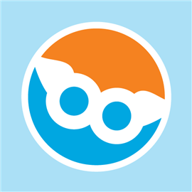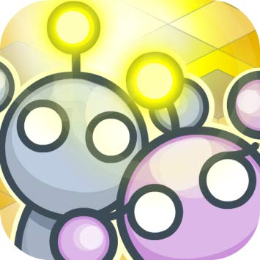

**Second Grade**

Second grade is working on non fictional books of their choice. The are learning how to read non fictional texts, find, locate, sort through information on the web, and site their source. The students are motivated to work on these because they are choosing a topic that interests them. Some are choosing animals, solar system, science, technology and more! They will be excited to share their work during a publishing party!

**Special thanks to the PS 166 Parents**

**Just wanted to thank everyone for supporting my last Donors Choose iPad project! There are so many wonderful educational applications for students with special needs use! They are a wonderful addition to the ICT classrooms.**

**THANK YOU! – Jenny Sora**

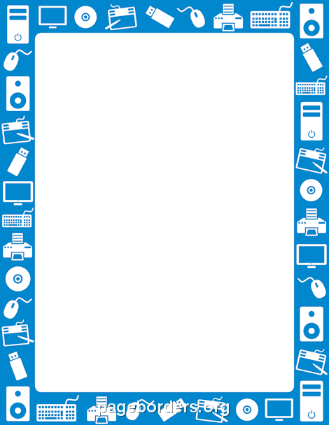

**Second Grade – Fifth Graders**

Throughout the year, ALL students will be using TypingWeb. Each student has an individual account and can sign on from anywhere. Typing is encouraged at home. In class, if students finish assigned work early, they are encouraged to sign on and practice. It is important students type well and fast to prepare themselves for online testing and typed projects in their very near futures!

**3rd Grade**

3rd grade is going to code using a program called Lightbots.

They will need to finish the program by the end of the year!

**Third through Fifth Grade: Finishing Scratch Projects**

Final weeks with Scratch… Students are completing their final projects! Their work and collaboration has been amazing! She the bulletin board for special tips on what makes collaboration work. Each class will be sharing their program with other grades. They are excited to showcase their fun and exciting programs.

**Fourth- Fifth Grade: Codesters**

**What is Codesters?**

Codesters combines a fun online coding platform for students, a powerful learning management system for teachers, and built-out coding lessons so you can start teaching kids to code in your school today.

**CODING PLATFORM**

Codesters lets students create interactive projects in Python. A drag-to-text toolkit guides students through text-based coding, while engaging them with sprites and animations.

**CURRICULUM**

Students use Python to build projects through structured lessons, then modify their code to create custom projects. Codesters use multiple exit points to support differentiated instruction.

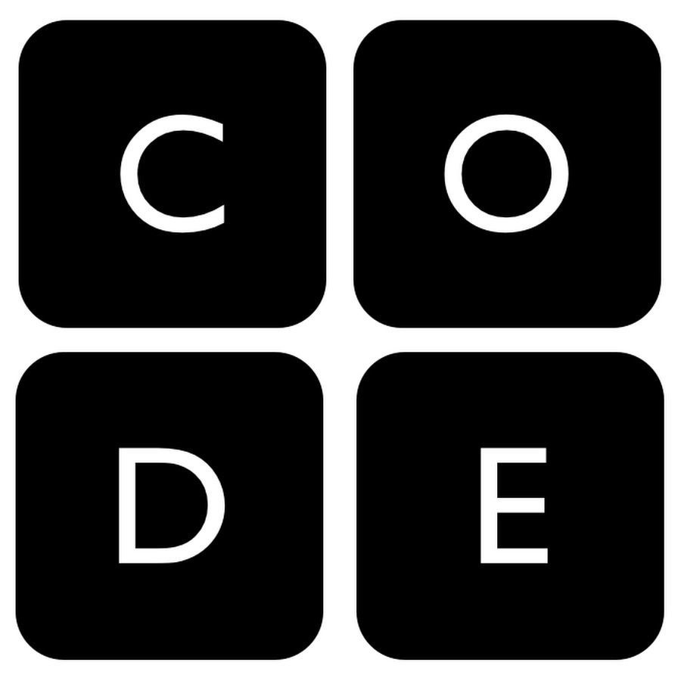

**First Grade**

**Coding, Coding, Coding**

We continue to focus on coding. We meet twice a month. Each week we meet, the students are learning the skills that accompany coding. Students will learn how to problem solve by solving complex problems and breaking them down into smaller steps. When the students complete Course 1, we will be starting Reading Responses using Pixie. Students will be able to type full sentences and illustrate pictures!

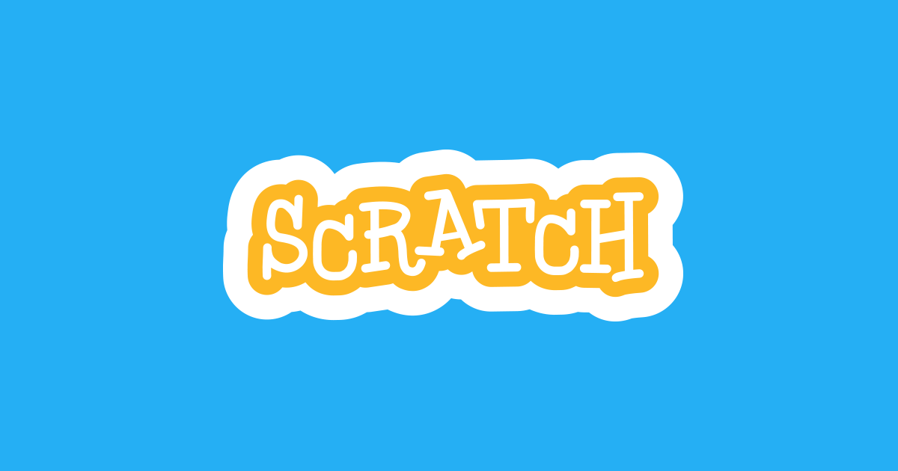

**May 2019**

**Technology**